Actual vs. Fake Job Posting Prediction: A Machine Learning Approach

Student-Name
IIT Reg Number
RGU Reg Number
Email
Course Work Title | MSc Project - BA
Research Supervisor
Word count | 20,000 words

CONSENT

- I agree
- I disagree

That the University shall be entitled to use any results, materials or other outcomes arising from my project work for the purposes of non-commercial teaching and research, including collaboration.

DECLARATION

I confirm:

- That the work contained in this document has been composed solely by myself and that I have not made use of any unauthorised assistance.
- That the work has yet to be accepted in any previous application for a degree.
- All sources of information have been specifically acknowledged and quotation marks distinguish all verbatim extracts.

Abstract

This study dives into the complexities of fraud job detection in imbalanced datasets, a common problem in machine learning (ML) applications. Using a large dataset of fake and genuine job advertisements, the study examines the effectiveness of several machine learning algorithms in detecting fraudulent behaviours, specifically in fraud detection of fake job advertisements. ML classifiers such as Support Vector Machine (SVM), Random Forest (RF), Decision Tree (DT), K-Nearest Neighbors (KNN), Logistic Regression (LR), and Neural Networks (NN) are rigorously examined, with a particular emphasis on performance criteria such as accuracy, precision, recall, and F1 score. Furthermore, the study uses the Receiver Operating Characteristic (ROC) curve analysis to assess the models' performance and capabilities. To address the imbalance between fake and legitimate cases in the dataset, the study investigates the use of oversampling strategies to reduce bias and improve the classifiers' prediction capability. Through thorough research, Neural Networks emerge as the most promising classifier with higher accuracy rates amidst class imbalance. Notably, the use of oversampling approaches, such as the Synthetic Minority Over-sampling Technique (SMOTE) or the Adaptive Synthetic Sampling Method (ADASYN), results in significant improvements in classifier performance measures. Despite advances in detection accuracy, precision, recall, and F1 score, the study recognises the limits of working with imbalanced datasets. Challenges remain in ensuring optimal performance across all classes, especially when the minority class is substantially underrepresented.
Furthermore, relying solely on traditional evaluation criteria such as accuracy and precision may fail to convey the intricacies of classifier performance. To address these constraints, the report proposes several alternatives for future research These include developing advanced oversampling strategies, improving assessment metrics to reflect better model performance in imbalanced classes, and trying out research on ensemble learning methodologies. By adopting these alternatives, research methods will be able to mitigate the difficulties of imbalanced datasets better, paving the way for future fraud detection systems that are more robust and efficient.
Keywords: Machine Learning, Neural networks, fraud detection, Ensemble classifiers

Actual vs. Fake Job Posting Prediction: A Machine Learning Approach

Table of Contents

Acknowdlegement 8
Chapter 1 - Introduction 9
1.1 Chapter Overview 9
1.2 Problem Statement 9
1.3 Research Question 10
1.4 Background 11
1.5 Aims and Objectives 12
1.6 Rationale 12
1.7 Scope of the study 13
1.8 Software to be used 14
1.9 Deliverables 15
1.10 Summary 15
Chapter 2 - Literature Review 16
2.1 Chapter Overview 16
2.2 Theories 16
2.2.1 Machine Learning 17
2.2.2 Natural Language Processing 18
2.2.3 Single Classifiers 18
2.2.4 Ensemble Classifiers 18
2.3 Critical Review 19
2.4 Gap Analysis 27
Chapter 3 - Methodology 35
3.1 Chapter Overview 35
3.2 Conceptual framework 35
3.2.1 Independent Variables 35
3.2.2 Dependent Variables 37
3.3 Hypothesis 38
3.3.1 Identified Hypothesis 38
3.3.2 Hypothesis Testing 38
3.4 Research Design 40
3.4.1 Purpose of the Study 40
3.4.2 Data Collection 40
3.4.3 Exploratory Analysis 41
3.4.4 Data Preprocessing 41
3.4.5 Feature Selection 42
3.4.6 Class Balancing 42
3.4.7 Model Testing 43
3.4.8 Model Evaluation 44
3.5 Chapter Summary 44
Chapter 4 - Data Analysis 45
4.1 Chapter Overview 45
4.2 Data Collection 45
4.3 Exploratory Data Analysis (EDA) 45
4.4 Hypothesis Testing 50
4.5 Correlation Analysis 50
4.6 Chapter Summary 51
Chapter 5 - Solution Design 52
5.1 Chapter Overview 52
5.2 Data Preprocessing and Data Transformation 52
5.2.1 Data Cleaning 52
5.2.2 Handling Missing Values 54
5.2.3 Data Transformation and Feature Engineering 54
5.2.4 Feature Selection 56
5.3 Model Testing and Evaluation 56
5.3.1 Decision Tree and Random Forest 56
5.3.2 Logistic Regression and Support Vector Machines 57
5.3.3 K-Nearest Neighbors 57
5.3.4 Neural Network Model 58
5.4 Model Evaluation Metrics 59
5.4.1 Random Forest Evaluation 59
5.4.1.1 Pre-Class Balancing Evaluation 59
5.4.1.2 Post-Class Balancing Evaluation 61
5.4.1.3 Conclusion 62
5.4.2 Logistic Regression Evaluation 63
5.4.2.1 Pre-Class Balancing Evaluation 63
5.4.2.2 Post-Class Balancing Evaluation 64
5.4.2.3 Conclusion 65
5.4.3 K-Nearest Neighbors Evaluation 66
5.4.3.1 Pre-Class Balancing Evaluation 66
5.4.3.2 Post-Class Balancing Evaluation 67
5.4.3.3 Conclusion 68
5.4.4 Decision Tree Evaluation 69
5.4.4.1 Pre-Class Balancing Evaluation 69
5.4.4.2 Post-Class Balancing Evaluation 70
5.4.4.3 Conclusion 71
5.4.2 SVM Model Evaluation 72
5.4.2.1 Pre-Class Balancing Evaluation 72
5.4.2.2 Post-Class Balancing Evaluation 73
5.4.2.3 Conclusion 75
5.4.3 Neural Network Model Evaluation 76
5.4.3.1 Pre-Class Balancing Evaluation 76
5.4.3.2 Post-Class Balancing Evaluation 79
5.4.3.3 Conclusion 81
5.5 Selection of the Best Model 82
5.5.1 Comparative Analysis 82
5.6 Chapter Summary 84
Chapter 6 -Discussion 86
6.1 Chapter Overview 86
6.2 Discussion on Key Findings 86
6.3 Recommendations and Implications 88
Chapter 7 - Conclusion 90
7.1 Limitations of the Study 90
7.2 Contributions of the Study 91
7.3 Scope for Future Research 92
References 94

List of Figures

Figure 1. Machine Learning Process 17
Figure 2. Research Design flow 40
Figure 3. Data visualization of job postings by country 46
Figure 4. Experience leveel required by job postings data visualization 46
Figure 5. Analysis of Employment type - experience 47
Figure 6. Analysis of Employment type - Education level 48
Figure 7.Distribution of Job postings based on text length 48
Figure 8. Word clouds of job description 49
Figure 9. Corelation analysis 51
Figure 10. Description of dataset 52
Figure 11. Printing dataset data types 53
Figure 12. Removing unwanted columns in data frame 53
Figure 13. Checking for missing values in the dataset 54
Figure 14. Pre-processing text 54
Figure 15. Handling missing values 55
Figure 16. Removing stop words 55
Figure 17. Creating a TF-IDF vectorizer 55
Figure 18. Confusion matrix for Random Forest 60
Figure 19. Performance metrics for random forest - pre balancing. 60
Figure 20. Performance metrics for random forest - post balancing. 61
Figure 21. Confusion matrix for Random Forest (re sampled) 62
Figure 22. Confusion matrix for Logistic Regression 63
Figure 23. Performance metrics for Logistic Regression - pre balancing 64
Figure 24. Confusion matrix for Logistic Regression (Resampled) 64
Figure 25. Performance metrics for Logistic Regression - post balancing 65
Figure 26. Confusion matrix for K- Nearest Neighbours 66
Figure 27. Performance metrics for K- Nearest Neighbours - pre balancing 67
Figure 28. Confusion matrix for K- Nearest Neighbours (Resampled) 67
Figure 29. Performance metrics for K- Nearest Neighbours - post balancing 68
Figure 30. Confusion matrix for Decision Tree 69
Figure 31. Performance metrics for Decision Tree - pre balancing 70
Figure 32 Confusion matrix for Decision Tree (Resampled) 70
Figure 33. Performance metrics for Decision Tree - post balancing 71
Figure 34. Confusion matrix for SVM 72
Figure 35. Performance metrics for SVM - pre balancing 73
Figure 36. Confusion matrix for SVM (Resampled) 73
Figure 37. Performance metrics for SVM - post balancing 74
Figure 38. Model Accuracy before balancing 77
Figure 39. Model Loss before balancing 78
Figure 40. Confusion matrix analysis before balancing 78
Figure 41. Confusion matrix for model before balancing 79
Figure 42. Model Accuracy after balancing 80
Figure 43. Model Loss after balancing 81
Figure 44. Confusion matrix analysis after balancing 81
Figure 45. Confusion matrix after balancing 82
Figure 46. Comparison of pre & post sample accuracies 83

List of Tables

Table 1. Gap analysis of existing studies 28

Table 2. Summary of evaluation of models 85

Acknowledgement

I am deeply grateful to my research supervisor ……….., Senior Lecturer, Informatics Institute of Technology, for his invaluable direction, support, and encouragement in completing this project. From the beginning to completion, his ideas and comments were far more useful in successfully completing this project. In addition, I'd like to express my gratitude to the entire academic staff of the Informatics Institute of Technology and Robert Gorten University.

Finally, I want to thank my family members for their unwavering support in ensuring the success of this project. They assisted me in balancing my work and academic lives, understood my needs, and provided me with time for the project.

Chapter 1 - Introduction

1.1 Chapter Overview
This chapter provides an overview of the research, including its history and research scope. In addition to discussing techniques, deliverables, and the study's justification, the problem statement and research question will address the research's fundamentals.

1.2 Problem Statement
Job fraud has arisen as a primary issue in online recruitment, compromising the credibility and integrity of digital job marketplaces (Dutta and Bandyopadhyay, 2020). These fake job advertisements regularly make false promises like flexible work schedules, tremendous pay, and remote work opportunities; nevertheless, their true purpose is to trick people into getting money or sensitive information (Quihui et al., 2023).In addition, fraudsters may post fake job postings in order to damage the reputation of a particular organization. (Dutta and Bandyopadhyay, 2020).

The advancement of digital technology has aided the spread of fake job advertising and marketing, exposing job seekers to a variety of threats consisting of identity theft, financial fraud, and phishing attacks. Existing methods for detecting fraudulent job postings depend closely on manual assessment procedures which can be time-ingesting, aid-intensive, and liable to human errors (Dutta and Bandyopadhyay, 2020). Furthermore, the ever-changing nature of fraudulent schemes makes detecting fake advertisments challenging. Hence, safeguarding job seekers from fake job postings has become a high challenge.

Businesses and job seekers are increasingly turning to data-driven decision-making, which includes predictive modelling, ML, and big data analytics. However, the use of such technologies to safeguard against job fraud remains unexplored compared to other fields. As a result, there is an urgent need to create more robust systems capable of distinguishing between real and fraudulent job advertisements on online recruitment systems.

The underlying question is: Can machine learning algorithms and natural language processing techniques be utilised to develop robust models capable of detecting fraudulent job advertisements with high accuracy? Furthermore, what are the major characteristics and trends associated with fraudulent job postings, and how can these be efficiently identified and used in the development of prediction models?
By implementing an efficient predictive modeling method specifically designed to meet the difficulties of identifying employment fraud in online recruitment platforms, this study aims to address the above discussed problems. This study tries to improve the safety and privacy of online recruitment sites via Machine Learning (ML) and Natural Language Processing (NLP), eventually developing a more secure environment for both companies and job seekers.

1.3 Research Question
The underlying hypothesis of this study is that advanced ML techniques might also be used to sort through the complex information provided in job postings and identify particular signs of fraud.ML has verified its effectiveness in some fraud detection fields, including cybersecurity and financial fraud (Brown, 2021; Zhao, 2023). By considering parsing text and metadata patterns that are difficult to analyze manually, ML algorithms such as Decision Trees, Support Vector Machines, Neural Networks, and new ones like CNNs and RNNs have shown promising results (Green & White, 2022; Alshebli, 2018).
Furthermore, the use of NLP in this context makes it more effective in understanding undeclared linguistic words of the job advertisement enhancing the capabilities of the system (Doe et al., 2023). Such algorithms can be effective in identifying job opportunities that are fraudulent based on the significant results they have achieved in the areas of sentiment analysis and content type. This study is meant to provide solutions to the existing issues by adopting and modifying the existing methods by taking the unique characteristics of the online job market into account. In the development and validation of an ML model that will give the web platform owners total control of job posting oversight and management, the goal will be to totally eliminate all the fake posts and closely monitor user security with the highest level of effectiveness.
Research Question: Can machine learning models effectively distinguish between authentic and fraudulent job postings by analyzing their textual content and metadata? This was the question we addressed in this project.

1.4 Background
The emergence of online employment platforms has brought a revolutionary change to the conventional recruitment method, presenting companies and job seekers with unrivaled comfort and accessibility. But with all of this digital change, there has also been an increase in fake job postings and fraudulent activity via online platforms. The term "job fraud" refers to a variety of fake jobs that put unwary job seekers at stake.These activities include phishing schemes, identity theft, financial scams, and fraudulent job advertisements. According to Smith & Johnson (2022), it is critical to enforce effective detection systems to protect clients and ensure their safety while using Online Recruitment platforms. Such systems can leverage job advertisement data to pinpoint fraudulent postings.
Fraudulent job postings exploit the vulnerability of job searchers by making exaggerated claims about job opportunities or career advancement. These fake job advertisements often bear a strong resemblance to genuine ones, making it difficult to identify them through traditional methods. Moreover, online platforms provide scammers with a more remarkable ability to execute their deceptive operations because of the anonymity they provide. According to a recent poll performed in the UK by ActionFraud, a significant majority of individuals (over 67%) who search for employment online without awareness of fraudulent job advertising or scams are highly susceptible to exploitation. According to reports, nearly 700,000 job seekers in the UK have allegedly been defrauded of more than $500,000 as victims of work scams. The investigation uncovered an almost threefold increase in the UK during the past two years. Scammers primarily focus on students and recent graduates who are willing to spend a higher amount for a secure career, as stated by Srivani et al. (2023). However, the current ways of detecting or protecting against cybercrime could be more effective as scammers frequently modify their techniques for impersonating job scammers.
Being a victim of employment fraud can have disastrous results, including identity theft, money losses, and reputational harm. Additionally, job fraud erodes the integrity of the hiring process and undermines confidence in online job sites. Therefore, it is imperative to have efficient detection systems employing AI to stop fraudulent activity and shield job searchers from falling for shady scams (Vuppala and Reddy, 2022).
Recent developments in NLP and ML have demonstrated significant results in tackling the difficulties associated with identifying employment fraud (Brown, 2021). It helps the researcher and practitioners to understand patterns and trends of job fraud with these techniques by analyzing job posting data. Advanced algorithms can be trained in a way that will notify the user to a given job posting that seems shady and, thereby, minimize the risks associated with online recruitement. In addition, if the contextual embedding models are employed to compare the similarity of job descriptions, there will be improvements in the the prediction, as Zhao (2023) stated.
All things considered, stopping employment fraud necessitates a multifaceted strategy that consists of technical improvements and user awareness programs. Online job platforms may establish a more secure and reliable environment for job searchers through a growing understanding of the risks of job fraud and implementing efficient detection strategies. This will enhance the recruitment system's integrity and construct trust in the digital job marketplace.

1.5 Aims and Objectives

- Assess and review the current state of ML models in detecting fake ones in online job postings.

- The goal is to identify the key features and patterns characteristic of fraudulent job postings through feature extraction, determining which independent variables (IV) have the greatest impact on the dependent variable (DV), i.e., the likelihood of a job posting being fraudulent.

- Develop and train a ML model capable of predicting the authenticity of job postings.
- Evaluate the models’ effectiveness and compare the performance to identify the best performing model.

1.6 Rationale
In addition to squandering job seekers' time and energy, fraudulent job advertising in online recruitment platforms exposes them to vulnerable security issues, along with monetary fraud, identification robbery, and phishing (Smith & Johnson, 2022). These fake postings compromise internet safety and security generally, as well as the credibility and integrity of online employment services. The intricacy of those fraudulent schemes, which employs up to date techniques to make detection challenging, emphasises the need for improved detection systems (Sabuhi et al., 2021).
The suggested use of ML and NLP provides a viable way to address these issues and examine the job posts' textual content and metadata (Datta et al., 2021). This methodology seeks to find patterns suggestive of fraud, along with unique wording, inflated advantages, and disparities, through methodically inspecting job advertisements. The indicators for the automated detection of fake job postings may be recognized and assessed by employing a ML model trained on a dataset that includes both legitimate and fraudulent job advertisements.
Specifically, fraud detection can be enhanced via the identification and deletion of fake ads with the use of ML and NLP. Thus, the automation of this process benefits the online job portal. Based on the provided context, the rationale of this study is to safeguard the legal group and job seekers by enhancing the dependability and credibility of online job portals (Smith & Johnson, 2022).
Moreover, it aligns with the objective of safeguarding the online recruitment industry from any attackers who may wish to threaten its digital frontier. The objective of this study is to raise awareness of the job market and minimize the impact of job scams by significantly reducing fake job postings. Hence, this project comes up with a novel approach to detect fake job postings (Sabuhi et al., 2021).

1.7 Scope of the study
The purpose of this research is to implement different ML and NLP techniques to evaluate and select the most effective algorithm for detecting fake job advertisements. By metadata analysis, the context of the functional task resume fake impostors will be aware of the significant indicators that serve as differentiating factors.The underlying idea of the project is to address the online fraud issue and to create a trustworthy process of verification of job postings on the Internet. By this comparison, we can become aware of the most outstanding ML model to improve the safety of online job marketplaces, demonstrating how technology can be used in tackling cybersecurity related concerns.
In computer science, there is a major confluence between ML, NLP, and cybersecurity regarding online job postings. According to Alshebli (2018), the massive volume of unstructured online job ad data requires the analysis and interpretation of ML and NLP. Moreover, cybersecurity in the digital age is driven by the need to recognize and prevent fraudulent activities in digital platforms (Smith & Johnson, 2022).
Complex models have been created as a result of text data analysis using ML and NLP techniques. According to Brown (2021), these algorithms are exceptional in detecting. Furthermore, cybersecurity issues emphasizes the need for dependable and safe methodologies to safeguard users from internet threats, as Green & White (2022) stated.This multidisciplinary approach advances computer science by using theoretical understanding and computational methods to address concrete problems in the real world, while also improving fraud detection mechanisms. The attempt to employ machine learning to distinguish between real and fraudulent job postings is an example on how technology can be utilised to maintain the security and integrity of online job marketplaces.

1.8 Software to be used
The project will utilize a comprehensive suite of tools and technologies prevalent in the field of data science for its development and implementation, including:

- Python: Selected for its extensive library ecosystem, Python is ideal for scripting and developing models due to its flexibility and ease of use.

- Graphical User Interfaces (GUIs): The project will incorporate GUIs such as Orange, Weka, and Azure Machine Learning Studio Classic for intuitive model development and analysis.

- Machine Learning Libraries: The project will employ Scikit-learn, TensorFlow, and PyTorch for machine learning tasks. Each of these libraries offers unique capabilities for data analysis and deep learning applications.

- Natural Language Processing (NLP) Libraries: NLTK and SpaCy will be used for efficient text data analysis, leveraging their powerful NLP tools to process and analyze job postings.

- Pandas: A library for data manipulation and analysis, enabling sophisticated data structure handling and operations.

- NumPy: Essential for numerical computing, NumPy supports high-level mathematical functions and multi-dimensional array operations.

- Data Visualization Tools: Matplotlib and Seaborn will be utilised to create informative and attractive data visualisations, facilitating the interpretation of results.

- Interactive Coding Environment: Google Colab Notebook will be used for its interactive coding capabilities and ease of documentation, providing a versatile platform for model development and testing.

- Microsoft Word: Microsoft Word will be employed for word processing due to its comprehensive features for document creation, editing, and formatting. It's widely used for professional report writing and will facilitate the organization and presentation of the project's findings.

- Zotero: Zotero will be utilised as a referencing tool to manage and cite references throughout the report. It offers an efficient solution for collecting, organizing, and integrating citation data with Word documents, ensuring accuracy and consistency in bibliographic information.

1.9 Deliverables

- Comparison of machine learning (ML) models to identify the most effective method for detecting fraudulent job posts.

- Evaluation of each model's performance, efficiency, scalability, and the significance of features through in-depth analysis.

- Selection of the best-performing model based on empirical evidence and analytical insights.

- A comprehensive report documenting the chosen model, including comparative analysis, decision rationale, and key findings.

Anyhow, the main deliverable is to effectively evaluate both ML and NLP models to address the problem of fraudulent job postings, specifically on digital platforms.

1.10 Summary

As discussed above this chapter mainly focuses on the background of fraud job postings and how ML,NLP can be effectively used to tackle these challenges.

Chapter 2 - Literature Review

2.1 Chapter Overview

This chapter focuses on reviewing existing studies on machine learning, Natural Language Processing, and methods for identifying fake job advertisements. Finding gaps in the literature will help create more efficient fraud detection techniques.

2.2 Theories
Fraud Job scams are online job advertisements that are fraudulent and primarily interested in obtaining the personal and professional information of job searchers rather than matching them with suitable positions (Mehboob and Malik, 2021; Srivani et al., 2023). In this technological era, instead of traditional approaches, studies are being carried out on the use of technology for fraud job detection. Most of the studies have used ML approaches (Anita et al., 2021; Quihui et al., 2023; Srivani et al., 2023).

As per the study (Anita et al., 2021), the common methodologies used for fraud job posting detection can be summarized as follows,

- Making use of publicly accessible datasets to identify fraudulent employment (Vidros et al., 2017).

- Classifying genuine jobs from fake ones using ML techniques from a database of job postings (Alghamdi and Alharby, 2019; Dutta and Bandyopadhyay, 2020)

- Increasing the accuracy of ML systems with the use of ensemble classification modeling (Alghamdi and Alharby, 2019; Dutta and Bandyopadhyay, 2020; Van Huynh et al., 2020).

- Textual data is analyzed semantically for the purpose of relation bridging and data forgery detection.

- Employing N-gram analysis (Ahmed et al., 2017) to identify and categorize categorical data

- Textual data features are extracted through the use of semantic analysis and natural language processing (Dhinesh,2023; Kumari, 2023;Ranparia et al., 2020), which also boosts efficiency.

- Utilizing sophisticated classification techniques, like the XGBoost algorithm (Mehboob and Malik, 2021), to increase classification accuracy.

Anyhow, majority of the studies commonly used Machine Learning, Deep Learning, Natural Language Processing, Sequential Networks, Single Classifiers and Ensemble Classifiers in this context (Dutta and Bandyopadhyay, 2020; Kumari, 2023; Reddy et al., 2024).

2.2.1 Machine Learning
ML is used to train algorithms that examine complex patterns and characteristics found in job postings, allowing the system to learn on its own (Reddy et al., 2024).The dynamic nature of fraudulent job advertisements must be addressed, and this adaptive learning process helps the system to improve its accuracy over time.ML algorithms are very good at deriving valuable insights from large datasets of job postings in the context of fake job post identification (Kumari, 2023). Consequently, the model can then be trained to detect language pointers, minor trends, and unusual behaviors which may stand as red flags for the possibility of fraud in job postings. Several improvements come with the use of machine learning which includes; the system becoming more adaptive and smart. These ML models are continuously updated and retrained. This is significant, as the model needs to be designed in such a way that it can navigate the negative impacts of fake job advertisements at all times. Figure 1.0 shows the process of machine learning.


Figure 1. Machine Learning Process

2.2.2 Natural Language Processing

NLP methods contribute to the requirements analysis, for instance, with the help of this method, it is possible to extract the relevant facts, mentality expression, and linguistic peculiarities from a given job description (Reddy et al., 2024). This allows for a greater state-of-the-art comprehension of the subtleties of language utilized in advertisements.Sentiment analysis,in which the system ascertains the general tone of a job advertisement can be achieved using NLP (Ranparia et al., 2020). This makes it easy to recognize possible warning signs or deceptive wording that is frequently connected to fraudulent postings.Furthermore, NLP allows for the identification of keywords and terms that link up to cheating behavior, which in turn results in multi-faceted and specific reports.

2.2.3 Single Classifiers

Support Vector Machines, decision trees, as well as logistic regression are instances of single classifiers (Dutta and Bandyopadhyay, 2020; Kumari, 2023) that work independently to offer facts on distinguishing among actual and fake job postings.As each classifier plays to its strengths, it creates an initial layer of analysis that is essential to the model concerning the usage of classification algorithms on structured data. Furthermore, the classifiers get knowledgeable through training, which helps them recognise the consistent patterns between valid and fraudulent job postings.

2.2.4 Ensemble Classifiers
Methods of ensemble classifiers have further enhanced the reliability and efficiency of the fraudulent job posting detection system. Ensemble classifiers employ the combined expertise of several models, such as Random Forests and Gradient Boosting (Dutta and Bandyopadhyay, 2020; Kumari, 2023). The ensemble methods provide an excellent prediction mechanism which is capable of beating most of the single classifiers by combining their results. Compared to the original categorization techniques, this tactical integration provides a more comprehensive and effective method for detecting fraudulent job advertisements as it takes into account the notable features of several categorization techniques. (Reddy et al., 2024).

Boosting is a form of learning technique that will improve category accuracy through creating a single model from several volatile novice models (Dutta & Bandyopadhyay, 2020). The boosting method adopts the weighted majority vote of the classifier series by applying the classification algorithm to both the reweighted training data.

2.3 Critical Review
Technology and business improvements have elevated employment options, and social media and internet platforms comes to play in online recruitment. In particular, recruiters and HR professionals tend to use Applicant Tracking Systems (ATS) for online recruitemnets.But with so many job postings, there are now more fake postings, which erodes confidence (Habiba et al., 2021). Moreover, fraudulent job ads are tricky and misleads job seekers more endangering their security, privacy, and general well-being (Mahbub and Pardede, n.d.). Sensitive information, such as complete names, addresses, phone numbers, and other details, might be obtained by fraudsters (Vidros et al., 2017). Nevertheless, advanced detection methods using ML, DL and NLP have been popular at the moment in addressing the issues encountered in the online recruitment industry. The literature review examines some important pieces of research that assist in comprehending and preventing online job fraud using ML,DL,NLP and other associated methodologies.

Van Huynh et al. (2020) proposed to use various deep neural network models, such as Text CNN, Bi-GRU-LSTM CNN, and BiGRU CNN, that have been pre-trained on a text dataset. They worked on classifying the IT job dataset. They trained an IT job dataset using the TextCNN model,which includes a convolution layer, a pooling layer, and a fully related layer. This version learned data using convolution and pooling layers. The training weights were then flattened and transferred to the fully connected layer. This model employed the softmax function as its optimization function. They also utilised an ensemble classifier (Bi-GRU CNN, Bi-GRULSTM CNN) using the majority voting technique to improve classification accuracy. They discovered 66% classification accuracy using TextCNN and 70% accuracy using Bi-GRU-LSTM CNN. This classification task fared best with an ensemble classifier, which had an accuracy of 72.4%.

Zhang et al. (2019) presented an automatic fake detector that uses text processing to discriminate between genuine and fake news (articles, creators, and subjects). They employed a dataset of news or articles uploaded to the PolitiFact website's Twitter account. This dataset was utilised to train the proposed GDU diffusive unit model.

Fake news detetction is a vital problem of studies in particular, given its massive impact on social and political discourse, as confirmed through its prominence in the 2016 US presidential election. Despite its importance, researchers need help with unrestricted funding. The study by Ahmed et al. (2017) proposes a fake news detection model based on n-gram analysis and several machine learning approaches. By evaluating several feature extraction methods and classification algorithms, discovered that TF-IDF and LSVM are the most successful combination, with an accuracy of 92%.

Moving on specifically to the domain of fake job postings, Vidros et al. (2017) recognized job scammers as fake online job advertisers, and this was the first mention of online recruitment fraud. They discovered data regarding numerous well-known businesses and organisations that created fake job postings with bad intentions.

In 2017, they published a follow-up to the earlier paper where they tested several classification methods, specifically the Naive Bayes classifier, random forest classifier, Zero R, One R, and others, on the EMSCAD dataset. With an accuracy of 89.5%, the Random Forest Classifier had the greatest performance on the dataset. They discovered that logistic regression needed to be fixed with the dataset. When they experimented with balancing the dataset, one R classifier performed admirably. In their work, they attempted to identify the issues with the Online Recruitment Fraud (ORF) model and to address those issues with a variety of dominant classifiers.

Without overcomplicating the problem domain, Raza et al. (2022) seek to provide a Python-based online application that only displays real job advertisements, hence improving the job search experience. This is made possible by using Support Vector Machines (SVM). It provides simplicity, cost savings, and an extensive work database. With user-friendly features and a focus on authenticity, it has the potential to safeguard users from fraud.

Studies using the EMSCAD dataset highlight the similarities between online recruiting fraud and different well-studied online scams, including phishing and cyberbullying. Despite its contributions, drawbacks encompass facts, scarcity, and language barriers. Future directions could focus on inspecting specific data mining methods and increasing dataset analysis. Nasser and Alzaanin (2020) investigated machine learning classifiers for fraudulent job postings. Following preprocessing and feature extraction, the classifiers were trained and evaluated using the term frequency-inverse document frequency. Random Forest emerged as the promising model, confirming previous studies on its efficacy with large datasets. Hence, this emphasises the significance of preprocessing and model selection in text categorization tasks.

Papat et al., (2023) presented a ML-based detection technique that compares job posting URLs to pick out actual and fraudulent classified ads. Based on findings from five research publications, we established that the random forest algorithm provides the maximum accuracy among accessible options. Using this approach, it builds a model with randomised parameters to classify job ads. Job seekers can also right away check the veracity of a posting through coming into a URL, which allows job seekers to navigate online opportunities. Anyhow, previous research has mostly concentrated on descriptive evaluation and proposed detection models, while less significant research has been carried out to look at realistic fraud detection techniques. This study by Alghamdi and Alharby. (2019) contributes by proposing a dependable ensemble-based detection model with a record accuracy of 97.41%. They ran experiments on the EMSCAD dataset using a machine learning method. They worked on this dataset in three steps: data pre-processing, feature selection, and fraud detection with a classifier. During the pre-processing step, they deleted noise and HTML tags from the data to preserve the broad text pattern. They used the feature selection technique to limit the number of attributes effectively and efficiently. Support Vector Machine was utilised for feature extraction, And an ensemble classifier based on random forest turned into employed to come across fake job postings inside the take a look at statistics. The random forest classifier was a tree-established classifier that was accomplished as an ensemble classifier. This classifier had 97.4% accuracy in deetcting fake job posts.

The associated work in Naudé et al. (2023) investigates machine learning algorithms like Random Forest, Logistic Regression, SVM, AB, GB, etc, to detect fake job adverts. It emphasises the significance of features, citing rule-set-based, bag-of-words, word embedding, and transformer models.Furthermore, it emphasises the importance of contextual and linguistic characteristics in discriminating between various forms of fake job advertising. The consequences exhibit the performance of a Gradient Boosting classifier,which achieved an F1-score of 0.88.

Recent studies have ordinarily centred on comparing diverse data mining techniques and getting to know techniques to discover which strategy is the best. Habiba et al., (2021) compared the application of K Nearest Neighbours, decision trees, support vector machines, naive Bayes classifier, random forest classifier, multi-layer perceptron, and deep neural network approaches to train a machine learning model using the Employment Scam Aegean Dataset (EMSCAD) to predict fake job postings . This study suggests that the deep neural network outper4forms all other models , marking an accuracy of 98% .

In their paper Quihui, et al. (2023) contribute with new ideas by offering an exhaustive evaluation of machine learning techniques utilized for the detection of deceptive job posts. The paper uses the EMSCAD dataset and feature engineering techniques to investigate the effectiveness of logistic regression, MLP, decision trees, and random forest algorithms in effectively recognising fake job adverts. Research makes it obvious that such an approach should be used to prevent the rised of online job fraud.

Othman Alandjani, (2022) uses different models that detect fake job postings. The study will use a Kaggle dataset of 17,880 job adverts to determine whether they are fraudulent or authentic based on a variety of factors. Given the dataset's abnormalities and missing values, thorough data preprocessing is required. Supervised learning algorithms that have been utilised are Naive Bayes, SVM, decision tree, random forest, and K-Nearest Neighbor. Notably, with k=5, the K-Nearest Neighbor classifier demonstrated promising results, while a Random Forest model with 500 estimators performed notably..

The proposed study by Vuppala and Reddy (2022) complements the investigation field by coming up with an automated system that identifies and dismisses fraudulent job ads ensuring safe surfing by job seekers.By applying ML and NLP methods, academia is trying to come up with a more effective methodology for the detection of fake job posts. This research offers an understanding of the experts and guides in this field, that lay a solid platform for preventing fraudulent recruitment on the online employment portal.
This paper (Kumari, 2023) compares different classifiers on a dataset with real and fake job posts. Several algorithms, including Naive Bayes and the SGD Classifier, are trained and tested to accurately predict fraudulent employment. The outcomes show the effectiveness of the strategies and rules applied in the job fraud detection process.

Dutta and Bandyopadhyay, (2020) suggested an automated system that uses machine learning-based classification approaches to avoid fraudulent job advertising on the internet. The findings of various classifiers are compared to determine the most effective job fraud detection algorithm. These classifiers are used to detect fraudulent job posts on the internet. It helps identify fake job advertisements by considering two types of classifiers: single classifiers and ensemble classifiers. However, experimental results demonstrate that ensemble classifiers outperform single classifiers in the context of fraud detection.

Amaar et al. utilized six machine learning models to determine whether the job advertisements were fake or not. They then evaluated all models with both BoW and TF-IDF to assess the model’soverall performance. One of the issues in this study is the dataset they have used. The ratio of authentic and fake job postings is imbalanced, resulting in model overfitting. To circumvent this issue, researchers used the adaptive synthetic sampling strategy (ADASYN), which helps to equalize the ratio across target classes by increasing the number of samples for the minority class. However, they carried out two experiments one with the balanced dataset and the other with the imbalanced data. ETC obtained 99.9% accuracy through experimental analysis by oversampling with ADASYN and extracting features using TF-IDF. Furthermore, this study compares our suggested approach to cutting-edge deep learning models and alternative re-sampling strategies.

Many more researchers use Natural Language Processing (NLP) to detect linguistic trends in fraudulent job advertising. Mehta et al. (2022) employ NLP to read and analyse the job post, followed by a machine learning model to predict whether it is real or fraudulent. The dataset used is EMSCAD. Moreover, NLP was used to convert the text data into matrix form, and then it was fed into the model for detection. As per the results, SVM has shown higher accuracy.

This paper (Chiraratanasopha and Chay-intr, 2022) discusses a new approach to distinguishing fake and fraudulent job adverts that target the behavior of the fraudsters. Unlike classic text-analysis methods such as term frequency, this methodology includes features based on missing information, exaggeration, and credibility, resulting in a more nuanced detection strategy. Additionally, readability scores are used to improve accuracy by taking into account textual complexity. Empirical testing utilizing machine learning techniques verifies this method's ability to identify fake job adverts effectively. Overall, the study gives out practical suggestions and different ways to fight employment scams and online fraud, which can be useful to job seekers and help maintain the integrity of online recruiting platforms.

(Mehboob and Malik, 2021) focus on the problem of identifying fraudulent/scammy recruiting. Their reduction is an approach to the organisational traits, job descriptions, and job types mentioned, as well as the process of recruitment fraud detection model. The extreme gradient boosting method is utilized g.It creates an algorithm for extracting required information from job advertisements and tests it with three samples. The features are then assessed in a two-step feature selection process. The hybrid composition of selected 13 characteristics achieved 97.94% accuracy, outperforming three state-of-the-art benchmarks. Furthermore, the study concludes that the most useful indicators are "salary_range," "company_profile," "organization_type," "required education," and "has multiple jobs."

The study by Jagadeesh et al., (nd.) examines two types of classifiers: single classifiers and ensemble classifiers, with the latter showing better results for detecting fake job postings. Within the single classifier category, the study uses a variety of techniques, including Naive Bayes, Multi-Layer Perceptron Classifier, K-nearest Neighbor, and Decision Tree Classifier. What enables the ensemble technique to perform more favourably are random forest classifiers and boosting algorithms such as AdaBoost and Gradient Boosting.

In addition to an MLP with five hidden layers of size 128, 64, 32, 16, and 8, a K-NN classifier with k set to 5 was used for prediction in Refonaa, (2022). Random Forest, AdaBoost, and Gradient Boost classifiers were used with 500 estimators. Training data was allotted appropriately, and the dataset was used to assess the models’ performance and accuracy. The findings were evaluated by comparing predicted values to original values to determine the efficacy of the categorization models.

Recently, in 2019, an online recruitment fraud detector was developed (Lal et al., 2019). They used an ensemble model to create the proposed technique and tested it on the EMSCAD data. They stated that their ensemble-based strategy achieved 95.4% accuracy and a 94% F1 score. However, the authors did not consider the imbalance aspect of the EMSCAD dataset.Then, (Alghamdi and Alharby, 2019) presented another ensemble-based strategy for detecting online recruitment fraud. They used the EMSCAD dataset and support vector machine was used for feature selection.Meanwhile they used Random Forest as the classifier. The results showed that the random forest-based ensemble model outperformed the baseline. However, this study's drawback is also that they should have taken steps to balance the extremely imbalanced EMSCAD dataset.

Machine learning and deep learning algorithms are applied to pre-processed data in Anita et al. (2021) to detect fake job advertisements reliably. Logistic regression, KNN, and random forest are used for classification, with Bi-Directional LSTM neural networks improving accuracy. In this work, the best algorithm is finally chosen from all the classifiers. Nevertheless, data cleaning has a considerable impact on algorithm performance, emphasizing its importance in classification accuracy refining. The efficiency of multiple classifiers is examined, indicating that Bi-Directional LSTM outperforms others in detecting fake jobs.
This paper explores the implementation of ANN in identifying fake job adverts. It uses a Multinomial Naive Bayes algorithm to discern between fraudulent and authentic job advertisements, hence improving online job search efficiency and user confidence. The study trains the model using a double-blind study approach and takes into account a variety of job posting forms. The Flask framework combined with Python makes the user experience easy and approachable (A P et al., 2021)
In Pillai's (2023) research, the bi-directional long short-term memory (Bi-LSTM) is adopted to detect fake job posts, and performs with 0.91 of AUC ROC and a precision of 98.71%. The examination emphasizes the capability of deep learning methods to hit upon fraudulent job postings by inspecting numerical and textual characteristics.It features the exercise of that model that is seen in strengthening up the public trust in the online employment system.
Zhang and Zheng (2018) offer a unique unsupervised learning algorithm for fraud detection based on bi-directional RNNs and Markov Transition Field. The architecture of the model allows it to analyze time series behavioral features. Their approach dramatically enhances the predictive potential of fraud detection structures by demonstrating the efficacy of analyzing sequential records to hit online fraudulent sports. Van Zeelt (2024) investigated the utility of personalized PageRank (PPR) algorithms in analyzing the social dynamics of fraud, explicitly inspecting the connections among financial bills. Incorporating community feedback into fraud detection approaches will enhance accuracy and also allow for the formation of pertinent attitudes towards the monitoring system.
Gulshan P, Mukund T, Ajay A, Pankaj Kumar, Aruna M G, and Dr. Malatesh S conducted a key study on the prediction of false job advertisements during the pandemic. Using advanced deep learning and machine learning classification methods, the study investigates techniques such as KNN, decision trees, support vector machines, naive bayes classifier, random forest classifier, multilayer perceptron, and deep neural networks. The study, which was carried out on a dataset of 18,000 employee samples (EMSCAD), demonstrated the applicability of the proposed deep neural network classifier, which had an amazing classification accuracy of nearly 98% for recognizing fake job postings (Gulshan et al., n.d.).
Tax et al. (2021) states the importance of considering the organizational context in which systems learn model’s characteristic for fraud detection.Bao, Peng, Wu, and Li (2018) investigate the effectiveness of distributed model studying structures in using significant datasets for fraud detection.
To identify between legitimate and fake job adverts, this study (Srivani et al., 2023) used a variety of data mining techniques and classification algorithms, including K-nearest neighbor, decision tree, support vector machine, naive Bayes classifier, random forest classifier, and multi-layer perceptron. Using the Employment Scam Aegean Dataset (EMSCAD) with 18,000 samples, deep neural networks (DNN) proved to be a very good classifier, predicting false job advertising with an accuracy of nearly 98%. These findings highlight the critical role of modern machine learning technologies in combating online recruitment fraud and protecting job searchers from false postings.
The research reveals the promising job fraud detection techniques via combining machine studying (ML) and natural language processing (NLP) tactics to create progressed and effective detection systems. The cognizance of superior deep learning models like Bi-LSTM and RNN, alongside the research of new features including network-primarily based features and sequential behavioral data, reveal the field's shift toward more complex and context-conscious strategies. In order to realize the necessity of complete policies, organisational and operational models should be mentioned when implementing online job fraud technologies.
Kumar et al.'s study (2023) improves on some existing research that uses machine learning, natural language processing, and feature engineering techniques to detect job scams. Moreover, it involves the broader field of fraud detection in online platforms, which is in line with actions to fight deception and protect users from scams.

Devsmit Ranparia, Shaily Kumari, and Ashish Sahani were authors of the respective study papers that contributed a lot to this area. Their research investigates the application of SeqNLN and GloVe algorithms to classify and assess the legitimacy of job postings and NLP to extract trends from job descriptions.The study emphasizes real-world application by testing the model on LinkedIn job postings, demonstrating a holistic strategy for addressing the issue of fraudulent job advertisements (Ranparia et al., 2020).

The deployment of the Multi-Criteria Decision Making (MCDM) in the decision support systems (DSSs) is highly favored as this technique is widely acknowledged in the literature. One such method, Elimination Et Choix Traduisant la Realite (ELECTRE), makes decision-making easier by evaluating alternatives using established criteria. Although a lot of work has been done on decision support systems, there needs to be more information about their use, specifically in web-based situations. This work (Suryanto et al., 2018) fills a gap by implementing the ELECTRE method in a web-based application, allowing for dynamic input and output functionality for alternatives, criteria, and user values. Using the profile matching method, this decision support system assists managers in selecting qualified candidates while reducing fraud risks through data-driven insights.

Following that, in 2018, Mahbub and Pardede proposed another recruiting fraud detection method and expanded the EMSCAD dataset (Mahbub and Pardede, n.d.). The contribution is to provide contextual qualities to the feature space. They used textual, structural, and contextual information and achieved the best results with a rule-based classifier. The study also emphasizes the significance of building sophisticated filtering algorithms built inside cloud-based recruitment platforms to prevent privacy breaches and security issues. However, future research directions include expanding the feature space with new feature classes and automating the extraction of contextual data with specialized search engines.Anyhow, they should have made more effort to balance the dataset, despite the fact that the original EMSCAD dataset is extremely skewed.

Later, a unique strategy for detecting fraud in job placement is introduced (Kim et al., 2019). Models are developed using a hierarchical cluster-based deep neural network. The proposed method outperformed traditional methods.The suggested HC-DNN method overcomes this disadvantage by utilizing hierarchical clusters within deep neural networks, resulting in more precise identification of fraudulent behaviors. HC-DNN's hierarchical structure incorporates anomaly characteristics and provides explanations for fraud types, making it a promising approach for enhancing fraud detection in job placement systems.
Moreover in recent years, may studies have been carried out in this context. The majority of this work was validated on the same EMSCAD dataset and focused on two key issues: improving prediction performance by experimenting with different classifiers (Anita et al., 2021; Dutta and Bandyopadhyay, 2020; Lal et al., 2019) and investigating whether the selection of features can be improved or expanded to build more robust models (Alghamdi and Alharby, 2019; Mahbub and Pardede, n.d.; Mehboob and Malik, 2021).

2.4 Gap Analysis

The following table summarizes the studies conducted in this context, highlighting their contributions and limitations.

Table 1. Gap analysis of existing studies

Study | Contribution | Limitation
(Ahmed et al., 2017) | Developed a false news detection model utilizing n-gram analysis and machine learning approaches, attaining 92% accuracy using TF-IDF and LSVMs. | Relied on restricted datasets, which could have improved the comprehensive analysis and generalization of findings.
(Zhang et al., 2019) | Investigate the ideas, strategies, and algorithms for detecting false news pieces, creators, and subjects on online social networks.  Uses explicit and latent features collected from textual data.  Proposes a deep diffusive network model that incorporates network structure information to improve detection accuracy.  Extensive testing on a real-world fake news dataset reveals that FAKEDETECTOR outperforms state-of-the-art models. | Reliance on a single real-world false news dataset (PolitiFact) may limit its applicability to different scenarios.  There is potential for additional research into model scalability and flexibility in developing fake news detection.  The proposed model must continue to be refined and validated against a variety of evolving fake news events.
(Lal et al., 2019) | Propose an ensemble learning-based algorithm for detecting online fraud. Shows the findings of a complete investigation of the suggested model using a real-world dataset.  Assessed the suggested model's performance on an unbalanced dataset. | Relies on a single publicly available dataset, which may only partially represent the variety of fake job ads across platforms and regions.  The suggested model's generalizability to additional datasets and platforms must be evaluated further to verify its usefulness in diverse scenarios.
(Vidros et al., 2017) | Tested naive Bayes, random forest Zero R, and One R on the EMSCAD dataset.  Random Forest Classifier performed well with an accuracy of 89.5%.  Logistic regression did not work well with the dataset.  One R classifier performed well when steps were taken to balance the dataset.  Assesses the first publicly available dataset of 17,880 annotated job advertising. | Relying solely on data mining and metadata analysis risks missing important scam indications.  The EMSCAD dataset may need to be more thorough, potentially biasing conclusions.  Expanding the dataset and ruleset may provide difficulties and affect generalizability.
(Alghamdi and Alharby, 2019) | Introducing a model based on the ensemble approach.  Support Vector Machine is used for feature selection, with Random Forest serving as the classifier.  Achieved 97.41% accuracy, the highest reported in this domain.  Identified crucial detection features, such as the firm profile and logo.  Closes a significant gap in studies on internet recruitment fraud. | A limited number of different datasets are available.  Complexity and variety in data types.  The dataset exclusively includes English-language commercials.  Future research could look into more data mining algorithms and increase dataset diversity.
(Raza et al., 2022) | Proposes a simple online tool using SVM and Python.  Focuses on user-friendliness and authenticity | Using less up-to-date technology.  Limited scope of job categories covered.
(Van Huynh et al., 2020) | Job prediction was investigated using deep neural network models such as TextCNN, Bi-GRU-CNN Bi-GRU-LSTM-CNN  Proposes an ensemble model that combines many deep neural network models to improve prediction.  Resulted in the greatest F1-score of 72.71% on the IT job dataset. | The dataset size is limited to 10,000 annotated job descriptions.  There is potential for improved dataset quality.  Future research into classical classifiers and deep learning models with diverse word representations.
(Nasser and Alzaanin, 2020) | Random Forest was identified as the most effective classifier for distinguishing between authentic and fake job posts. It performed strongly on large datasets and placed emphasis on preprocessing approaches and model selection. | Multinomial Naïve Bayes had reduced accuracy, presumably due to the enormous vocabulary size, highlighting the need for more research into feature selection approaches and model applicability in memory-constrained times.
(Naudé et al., 2023) | Developed and verified a machine learning technique for identifying fake job postings.  Used a variety of characteristics, including rule-set-based, transformer models, bag-of-words, and word embeddings.  Showed that word embeddings and transformer-based features perform better than rule-set features.  Contextual and linguistic indicators were identified to distinguish between identity theft, corporate identity theft, and multi-level marketing job adverts.  Gradient Boosting classifier that included empirical rule-set features, parts-of-speech tags, and bag of words vectors is best with a F1 score of 0.88. | Anonymization during GDPR compliance may have changed data, changing the original language links.  The dataset's temporal constraints raise issues.  Data obtained from 2012 to 2014 may not reflect current fraudulent methods.  The homogeneity of false advertisements limits the sample size and class balance.  Upsampling specific job categories may enhance dataset homogeneity.  There needs to be more certainty about model robustness due to hold-out validation's limited averaging of performance indicators.
(Anita et al., 2021) | Machine learning and deep learning techniques are used to distinguish accurately between fraudulent and legitimate job advertisements, demonstrating the efficiency of Bi-Directional LSTM neural networks in improving detection accuracy. | The use of pre-processed data emphasizes the significance of rigorous data cleaning.
(Habiba et al., 2021) | Proposes a comprehensive strategy for detecting fake job posts based on various data mining techniques and classification algorithms ( ML, DL) using the EMSCAD dataset.  Deep neural network classifiers achieve great accuracy, reaching roughly 98% accuracy in detecting fake job postings. | Dependence on the size and scope of the EMSCAD dataset may restrict the results' generalizability.  The variation in effectiveness between classifiers emphasizes the need for additional investigation and optimization of algorithm selection.  Potential biases or inconsistencies in the dataset may have an impact on the robustness of the findings and the model's real-world application.
(Mehta et al., 2022) | Use of NLP techniques to assess job postings and distinguish between genuine and fraudulent offers.  The Employment Scam Aegean Dataset was used to train the ML model, allowing the solution to be applied in the real world.  Linear SVM (Support Vector Machine) is used as a prediction model to determine if job advertisements are genuine or fraudulent. | Reliance on the availability and quality of the Employment Scam Aegean Dataset may limit the model's capacity to detect various types of fake job advertisements.  The scope is limited to the capabilities of the ML model, which may only catch some nuances or evolving techniques used by scammers.  Dependence on NLP algorithms to correctly comprehend and analyze job advertisements, which language complexities and ambiguities might influence.
(Quihui et al., 2023) | Comparative study of ML (Logistic Regression, MLP, Decision Trees, Random Forest).  EMSCAD is used to train and test models.  Implementation of feature engineering techniques to improve model accuracy and efficacy at discriminating between real and fraudulent job adverts.  Demonstrate the usefulness of MLP and Logistic Regression in successfully recognising fake job advertising, with potential solutions for job searchers, employers, and job portals to limit the dangers associated with such postings. | Reliance on the EMSCAD dataset, which may not include all types of fake job advertising, potentially restricting the findings' generalizability.  The scope is limited to the examination of specific ML algorithms, eliminating any other alternative techniques or ensemble methods that could improve detection accuracy.  Potential bias in the feature engineering and selection processes, which could affect model performance and generalizability across multiple datasets or job posting sites.  Further optimization and fine-tuning of decision trees and random forest algorithms are required to improve performance metrics, particularly recall rate for detecting fake job postings.
(Vuppala and Reddy, 2022) | Use of Random Forest, AdaBoost, Linear SVC, Decision Tree, and Gradient Boost.  The use of NLP techniques (stop word removal, lemmatization, and tokenization) to preprocess job advertisements improves the classification model's efficiency. | Relying on supervised learning methods may limit the model's ability to recognize new types of fraudulent job posts that need to be captured in the training data.  The use of NLP in the preprocessing stage may add bias or inaccuracies, compromising the classification model's overall performance.  The scope is limited to classifying job ads as fake or real, perhaps disregarding subtle variances or subcategories of fraudulent activity.
(Chiraratanasopha and Chay-intr, 2022) | Proposes creating a collection of features customized to the behavior of fraudsters who make fake postings.  Identify three essential concepts - missing information, hyperbole, and credibility - as critical indications of fake job adverts, and develop features around these principles.  The use of a readability score (Flesch-Kincaid readability) to measure the difficulty of textual descriptions in job postings  ML approaches (KNN, SVM, and decision trees) are used to train the intended features. | Dependence on the annotated EMSCAD dataset may limit the suggested method's applicability to other datasets or situations with different characteristics.  Relying on machine learning approaches may bring bias or mistakes into the detection model, especially if the training data does not cover all conceivable versions of fake job adverts.  Complexity of content, while measured by readability ratings, may not capture all nuances or intricacies of fraudulent postings, thereby leading to false positives or false negatives.  Manual intervention or human oversight may be required to validate the effectiveness and dependability of detected fake job adverts in real-world circumstances.
(Jagadeesh et al., n.d.) | Comparative examination of single and ensemble classifiers for detecting fraudulent job postings.  A demonstration of the Decision Tree Classifier as an effective single classifier.  Ensemble classifiers such as Random Tree, AdaBoost, and Gradient Boost were evaluated and shown to perform better.  The Random Forest Classifier was identified as the most effective model because of its high accuracy, Cohen-kappa score, and F1 score. | Reliance on experimental outcomes without taking into account real-world data variability.  The proposed approach's generalizability across different labor markets or geographies has yet to be investigated.  The dataset's particular properties cause potential bias or overfitting difficulties.  The lack of a thorough investigation of false positive and false negative cases limits insights into model performance.
(Mehboob and Malik, 2021) | An effective recruitment fraud detection model was developed utilizing the extreme gradient boosting (XGB) approach.  Proposal of key aspects for fraud detection, including organizational structure, job descriptions, and compensation types.  The XGB-based model outperformed three state-of-the-art baselines, with an accuracy of 97.94%.  Identification of crucial indicators for fraud detection  The use of a unique algorithm for feature extraction and selection resulted in the identification of 13 critical features for fraud detection.  Practical ramifications include job seekers verifying the legitimacy of job advertising, particularly those posted by recruitment firms, and employers improving fraud detection mechanisms in online recruitment procedures. | Lack of an online application for evaluating real-world scenarios.  More research into robust features is needed to improve the effectiveness of fraud detection models.  Reliance on a single dataset (EMSCAD) for studies, limits generalizability to other datasets or situations.  The chosen machine learning methods and feature selection procedures may introduce bias or limits.  Future research should explore the multidimensional aspects of online recruiting fraud detection more deeply and investigate new characteristics for model refining.
(Kumar et al. 2023) | Compilation of a comprehensive dataset that includes numerous job listing information.  Utilization of cutting-edge machine learning techniques, such as natural language processing and feature engineering.  Identification of patterns and traits that identify real job opportunities from fraudulent ones.  Individuals' job-seeking experiences are expected to improve, as will support from employment platforms, companies, and regulatory authorities in combating false job advertisements.  Adopting a supervised technique to demonstrate the efficiency of various classifiers.  The Random Forest classifier's superiority in spotting fraudulent job offers is demonstrated with an amazing accuracy rate of 98.27%. | Lack of attention to real-world data fluctuation and changing scam methods.  There is no extensive examination of false positives and false negatives cases.  The proposed methodology's generalizability across different labor markets or geographies has yet to be thoroughly investigated.  The theoretical framework may need to address the dynamic issues driving the online job market entirely.
(Othman Alandjani, 2022) | Experimented with several supervised learning algorithms, such as Naïve Bayes, SVM, decision tree, random forest, and K-Nearest Neighbor.  The K-Nearest Neighbor classifier produced encouraging results with a k value of 5.  Developed a Random Forest model with 500 estimators that was effective in detecting fake job ads. | Dataset preparation was required because of anomalies and missing values.  Model efficiency may vary depending on the dataset's specific properties.  The dataset's quality and completeness may influence the classifiers' performance.  The scope and size of the dataset employed may limit the study's findings.  More study is needed to determine the findings' generalizability across various datasets and circumstances.
(Mahbub and Pardede, n.d.) | Introduces a new feature space for identifying online recruiting fraud (ORF).  Contextual factors improve the efficacy of multiple classifiers.  Implementation of intelligent backend filtering systems based on this methodology could help detect fraudulent job posts and protect users' privacy and security on job advertising platforms. | Future enhancements could include the addition of new feature classes to increase detection capabilities.  Automation of contextual feature extraction is critical for scalability and validity; yet, it may provide accuracy and data validation issues.  Incorporating network information and user behavior analysis could improve the detection system's effectiveness, although creating large-scale datasets for such analysis may be resource-intensive.
(Kim et al., 2019) | Introduction of Hierarchical Clusters-Based Deep Neural Networks (HC-DNN) for detecting fraud in job placement processes.  To capture anomaly characteristics, hierarchical clustering was used within deep neural networks that had been pre-trained using autoencoders.  Improved fraud detection performance over standard methods such as decision trees, logistic regression, SVM, gradient boosting, random forest, and even CNN or neural networks.  The hierarchical cluster structure provides insights into numerous types of fraud, making it easier to explain fraud characteristics. | Overfitting issue  Data Privacy and security concerns

Chapter 3 - Methodology

3.1 Chapter Overview

The methodology involved in building a machine learning model for identifying potential fake employment ads are outlined in this chapter. The process includes methods such as research design, data collection, data cleaning, data transformation, and data reduction, model building, model evaluation, and interpretation of results. Each stage is optimized to work with the data set, which contains both text and meta-information from job postings. The first stage pertains to the methodology that is anchored on the research design, which has been developed along the lines of a machine learning-based predictive model that seeks to categorize the fake and the real job posts. This is very helpful in managing the data skew typical of fraud detection types of scenarios. The used dataset is from the University of the Aegean containing nearly 18,000 jobpostings out of which 800 job postings are fraud. They play a crucial role in screening the fraudulent postings in this feature characterized dataset. Data oversampling methods were applied because there were only 800 fraudulent jobs ads in the database.

Preprocessing includes steps such as data cleaning, hanling missing values, outlier management, and data transformation to prepare data for subsequent analysis. Feature selection is then done to identify the most relevant features. Several models are used to find the best among them for fraud detection, including performance metrics such as accuracy, precision, recall, and AUC. It ends with the assessment of the model and its results to identify more about the characteristics of the fraudulent statuses and further enhancement of the strategy. This kind of approach is very significant not only in establishing the stability and sustaining of the forecast model but also in the flexibility of the model that could always respond to different types of job frauds. Drawing from current literature and relevant findings, this chapter provides a clear and proper approach of moving online fraud detection forward in the domain of the job market.

3.2 Conceptual framework

3.2.1 Independent Variables

In this study, the independent variables are derived from the extensive details encapsulated within job postings, and classified broadly into two categories: textual features and meta-information. These variables are meticulously chosen to reflect aspects of the job postings that are most likely to indicate the presence of fraudulent intent.

Textual Features:

Textual features are central to the analysis as they directly describe the job and the employer, and are often manipulated in fraudulent postings to deceive job seekers. These include:

- Job Title:
The designation or title given to the job position, can sometimes be misleading or exaggerated in fraudulent postings.

- Job Description:
A detailed narrative that outlines the duties, scope, and nature of the job is critical. Fraudulent posts may include vague, overly simplistic, or overly enticing descriptions that do not match the title.

- Company Profile:
Description of the employer which might be fabricated or copied from legitimate businesses in fraudulent cases.

- Requirements:
Lists the necessary qualifications and skills required for the job. Fraudulent postings might list unrealistic skills or qualifications to appear legitimate or fail to provide detailed qualifications to cast a wider net for potential victims.

- Benefits Descriptions:
Often overstated in fraudulent postings to attract unsuspecting job seekers with promises of high rewards for minimal effort.

Meta-Information:

Meta-information provides structural context to the job postings, helping to identify patterns that may be consistent with fraudulent activities:

- Location:
The geographical area where the job is situated, which is in fraudulent posts, might be vague or prestigious locations to entice candidates.

- Department:
Indicates the specific division or segment of the company the job belongs to, potentially non-existent or misleading in fraudulent posts.

- Salary Range:
Often exaggerated in fraudulent postings to attract more candidates or exceptionally vague to avoid scrutiny.

- Employment Type:
Specifies whether the job is full-time, part-time, or freelance. Fraudulent posts may promote unusually flexible work arrangements to attract those seeking convenience.

- Required Experience:
The level of prior work experience needed might be incongruent with the job level or duties in fraudulent postings.

- Required Education:
The educational qualifications required for the position, could be either minimal or overly stringent in fraudulent postings to manipulate the appearance of legitimacy or exclusivity.

3.2.2 Dependent Variables

Fraudulent (Target Variable):

The dependent variable in this study is a binary indicator that classifies each job posting as either fraudulent (1) or legitimate (0). This classification is then made according to the textual and meta-information features created from the article contents and the results of the model. It also underlines the importance of the capability of detecting fake job offers as critical for safeguarding the users of online job search platforms and the integrity of the industry. By using the model’s outcome, details about job scams’ frequency and nature are provided for causal steps and policy strategizing. This framework is the basic design of the research, allowing for analysis of job postings and the use of machine learning based methods to discover suspicious patterns. These independent variables shall therefore be related to the dependent target variable with the aim of building a stronger model that would improve the detection of fraud in online job platforms.

3.3 Hypothesis

3.3.1 Identified Hypothesis

Certain textual and metadata features can significantly predict the authenticity of job postings.

This hypothesis assumes that certain elements of job postings such as the written job description, the company profile, or metadata containing location as well as salary range, will serve as the predictor for distinguishing fraudulent from legitimate job postings. The underlying assumption is that fraudulent postings exhibit distinguishable patterns in how they present this information, which can be systematically identified and quantified through machine learning models.

Patterns in Language can be used to make predictions

Phrasing patterns, syntactic structures, and targeted keywords are just a few examples of linguistic elements that can be used to distinguish real job posts from fake ones. As per the assumption, distinctive language features make fake job postings different from real ones.
NLP can be used to examine the patterns by analysing the textual fragments. Some instances include less-detailed job descriptions, spelling mistakes, informal language, or visually appealing material.

3.3.2 Hypothesis Testing

This hypothesis is then tested using the most advanced machine learning models, which can provide a great solution for classification problems when the data given are high-dimensional and have various complex structures. The chosen models are Support Vector Machines (SVM), Random Forests, and Neural Networks, each offering unique strengths in handling different aspects of the data and contributing to a robust analytical approach.

- Support Vector Machines (SVM):

The SVM method will be employed to make the optimal hyperplane, which will distinguish fraudulent from unbiased heuristic comments. SVM is particularly effective in high-dimensional spaces and can use a variety of kernel functions to handle non-linear data. The effectiveness of the model in this sense will be estimated by its ability to gain margin between the classes simultaneously, and this will be a major contributor to biomarker detection in such a complex space.

- Random Forest:

Random forest will be applied to measure the impact of the features by comparing their ability to reduce the uncertainties over whether the posted job is real or fake. This model works by constructing a multitude of decision trees at training time and outputting the class, which is the mode of the classes of the individual trees. This method is specifically suitable for this hypothesis as it is a straightforward way to analyze feature selection and verification of the influence of specific textual and metadata information.

- Neural Networks:

Neural Networks will be employed to handle the non-linear relationships that are very likely to occur in data. Given their ability to learn complex patterns through layers of interconnected nodes (neurons), they are well-suited for capturing subtle nuances in text and metadata that might indicate fraudulent intent. Layers will cumulatively yield and merge the features and become a tool that one can rely on when proving the hypothesis.

Testing Approach:

In every model, each dataset will be labeled for its authenticity (fake or authentic); and their performance will be evaluated based on how well they can distinguish fake from real with their classification accuracy, precision, recall, and F1 score. Logistic regression coefficients will also be used in a complementary capacity to quantify the impact of each feature on the likelihood of a posting being fraudulent. The indirect relationship between each feature and the result depends on the direction and evidence, thus empirically proving the hypothesis or refuting it.

This will also shed light on the features most likely to predict the incidence of fraudulent job postings, thereby establishing the theory on which the model is based. Finally, models' abilities and boundaries in fraud detection in job postings will also be shown. This knowledge will be brought to the machine learning science sphere, as well as online security.

3.4 Research Design

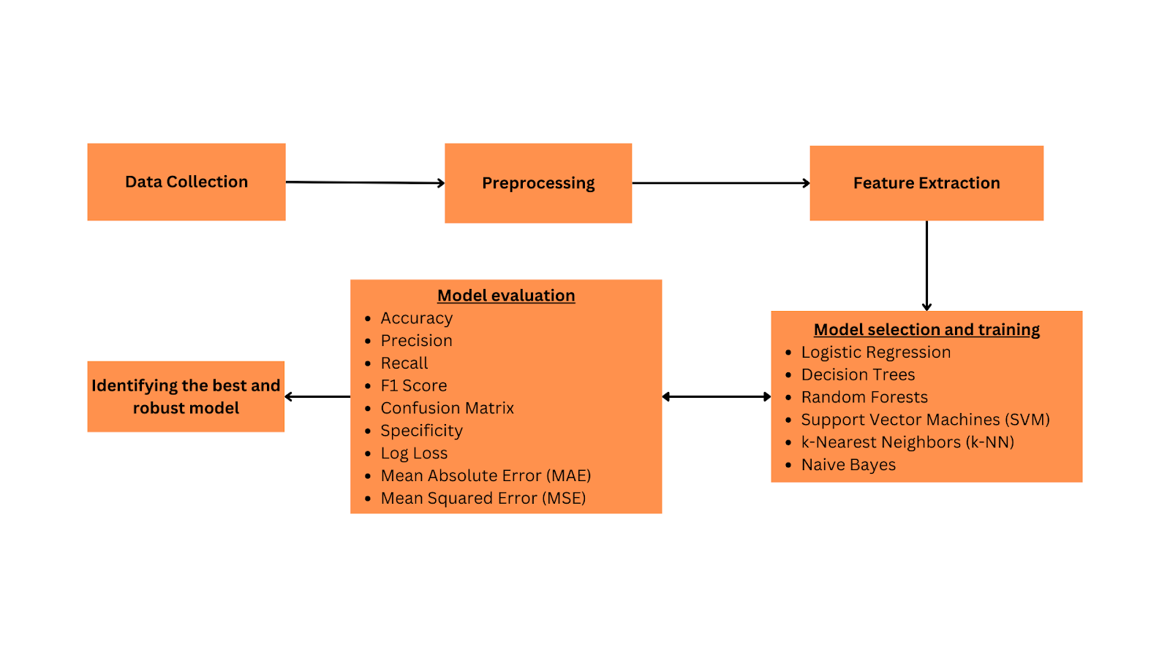

Figure 2. Research Design flow

3.4.1 Purpose of the Study

The primary purpose of my research is to build a highly accurate fraud detection model. This model aims to enhance the reliability of online job markets and safeguard job seekers from potential scams. The study fulfils the aim of having a safer job search atmosphere in which one can confide that job postings are not manipulated online.

3.4.2 Data Collection

The economics faculty of the University of the Aegean provided the data for the study. It comprises 18,000 job postings, of which approximately 800 are identified as fraudulent based on prior verification. This dataset is rich in both textual and meta information about job postings, providing a comprehensive basis for analysis. The amount and type of data ranging from jobs to industry and types of fraud will be used for the model training and validation. As a result, the model will be able to encompass a wide range of job types and a variety of fraud patterns simultaneously.

3.4.3 Exploratory Analysis

An exploratory analysis of the dataset is conducted to understand its structure and underlying patterns. This includes:

- Distribution Analysis:
Assessing the distribution of both numerical and categorical variables to understand the central tendencies and variability.

- Outlier Detection:
Identifying any anomalies that may influence the predictive accuracy or skew the results.

- Correlation Analysis:
Examining the relationships between different features, especially how they relate to the target variable of fraudulence.

These analyses help frame the preprocessing steps and guide the feature selection process, ensuring that the subsequent model development is based on well-understood data characteristics.

3.4.4 Data Preprocessing

- Handling Missing Values:
Missing values are replaced via imputation or excision, depending on whether they are missing completely at random or due to the mechanism involved. For numerical fields like salary range, mean or median imputation is used, while for categorical fields such as department, mode imputation or removal of records may be applied.

- Outlier Management:
Scaling methods of high intensity, such as transformations of outliers, are applied to the numerical data to reduce their impact. This ensures that the model's performance is not adversely affected by extreme values.

- Encoding Categorical Data:
Categories are encoded into a machine-readable format, so One-hot encoding is applied. This method converts categories into binary vectors, facilitating their incorporation into machine learning algorithms without implying ordinality.

3.4.5 Feature Selection

Automatic Feature Selection:
Techniques such as recursive feature elimination (RFE) are implemented to identify the most predictive features. This method iteratively refines the set of features by building a model and removing the least important feature until the optimal subset is determined. This process enhances model efficiency and helps in focusing on the most relevant attributes for predicting fraudulent job postings.

3.4.6 Class Balancing

There are only 800 fake job posts out of the total count of 18,000 job postings in the EMSCAD dataset. This clearly indicates a substantial class imbalance problem. We used the Synthetic Minority Over-sampling Technique (SMOTE) to rectify this imbalance and improve the identification of fake job postings. The most popular method used is SMOTE to generate more records for the minority class and address imbalanced datasets. To create new samples that effectively increase the representation of the minority class without merely reproducing existing examples it interpolates between current minority class samples. In this study, we were able to increase the number of fake job postings in the dataset by up to 2500 using SMOTE and Generative AI. Hence in addition to SMOTE, we also used sophisticated generative AI methods, notably ChatGPT to enhance the dataset further.

Specifically, using one of the most prominent generative AIs, ChatGPT, it was possible to generate more realistic and contextually relevant fake job postings. To facilitate this we had to examine and imitate the linguistic characteristics of the existing fraudulent job posts. By employing a combined approach it was easy to generate more real-looking samples of fake job posts. One of the major objectives of implementing an efficient fraud job detection system was fulfilled by balancing the dataset to some extent.

3.4.7 Model Testing

For the testing phase, various classifiers are employed to determine their efficacy in distinguishing between fraudulent and legitimate job postings. The selected models include:

- Support Vector Machines (SVM) :
SVM is utilized for its effectiveness in high-dimensional spaces, which is ideal for handling the complex feature sets derived from job postings. It works by finding the hyperplane that best separates the classes and is particularly useful for its robustness in non-linear classification through the use of kernel tricks.

- Random Forest :
This model uses an ensemble of decision trees to improve prediction accuracy and control overfitting, making it highly effective for handling our dataset's unbalanced nature. It is known for its ability to perform both classification and regression tasks with higher accuracy by averaging the results from various trees.

- Neural Networks :
Employing a neural network architecture allows for deep learning from the dataset. Neural networks are advantageous for their ability to model non-linear and complex relationships within the data. The layers within these networks can learn to identify subtle cues that indicate fraudulent activity, which more traditional models might miss.

- Logistic Regression:
Logistic Regression is one of the most commonly applied models and is known for its simplicity and high speed. This algorithm provides the odds of occurrence of a binary event through a logistic function and is ideal for evaluating the correlation of the features with the likelihood of a given job posting being fake. This makes it very useful for its interpretability and understanding of the impact each feature has on the prediction.

- K-Nearest Neighbors (KNN):
The KNN is a non-parametric algorithm that can be used to solve classification problems. It assigns a new data point to a class that is most frequently represented among its KNNs. This model is particularly efficient for datasets of small to medium sizes and gives rather comprehensible results. However, the KNN’s computation complexity is high, especially when the data set is large, and its efficiency is influenced by the value assigned to K and the distance measure used.

- Decision Tree:
This model can be implemented as a technique for feature importance analysis as it offers a clear architecture with clearly defined layers that shows how the decision is made. It divides the data into subsets in terms of the values of different features so it is easy to see how the decision flow is and it can be a problem of over fitting if it needs to be appropriately tuned. The other advantage of the Decision Tree model is that it is easy to interpret and to implement as well.

3.4.8 Model Evaluation

The effectiveness of each model is rigorously assessed using a variety of performance metrics:

- Accuracy:
This metric will help in evaluating the overall effectiveness of each classifier in correctly identifying both fraudulent and legitimate postings.

- Precision and Recall:
These metrics are particularly crucial given the class imbalance in our dataset. Precision will measure the accuracy of the positive predictions (real job postings), while recall will indicate how well the model can identify all relevant instances of fraud.

- F1-Score:
The F1 score will be used as a harmonic mean of precision and recall to balance the precision and recall measurements. This is essential in scenarios where equal importance is assigned to false positives and false negatives.

3.5 Chapter Summary

This chapter initially concentrated on the creation of the conceptual framework and how it linked to the findings of the literature review. Following the conceptual framework, testable hypotheses were constructed. Following the hypothesis, the study design was described, which included the flow of the research. The techniques of data collecting and analysis, as well as the essential technical tools utilized in the process, were also covered. Accuracy, F1 Score, Precision, Recall, and AUC-ROC Curve were defined as a matrix to benchmark the performance of 3 candidate models, namely Random Forest, Support Vector Machines, and Neural Networks.

Chapter 4 - Data Analysis

4.1 Chapter Overview

In this chapter, the authors expose the findings emerging from the study aimed at determining whether some textual and metadata aspects may contribute to the accurate detection of fake job posts. The methodology of analysis is given in detail, from the data collection to the exploratory analysis of data, hypothesis testing, correlation testing, and a summary of the chapters. Every step aims to describe the properties of the dataset systematically, analyse the connections between variables, and assess the predictiveness of the chosen features.

4.2 Data Collection

The dataset is obtained from the University of the Aegean: There are a total of 18,000 job postings out of which 800 are considered to be fraudulent. This dataset was selected because of their comprehensive number of text as well as metadata elements, which are essential for the study. This section explains how the data for this study was collected, how it was obtained and how all the data required to test the hypothesis of the study was obtained and processed for analysis.

4.3 Exploratory Data Analysis (EDA)

The exploratory analysis of the job posting dataset confirms the findings about the distribution of different jobs by country, level of experience, employment types, educational requirements, job scams, and the overall text of the job descriptions. All of them have been presented to present the patterns and trends in a manner that is most easily understandable.

1. Job Postings by Country :

The distribution of job postings by country shows a heavy concentration in the United States, followed by a significantly smaller number in Great Britain and Greece. This indicates a potential bias or target market focus in the dataset towards the U.S. job market. Such a distribution suggests that any global generalization of the results should be approached with caution, as the dataset is predominantly North American.
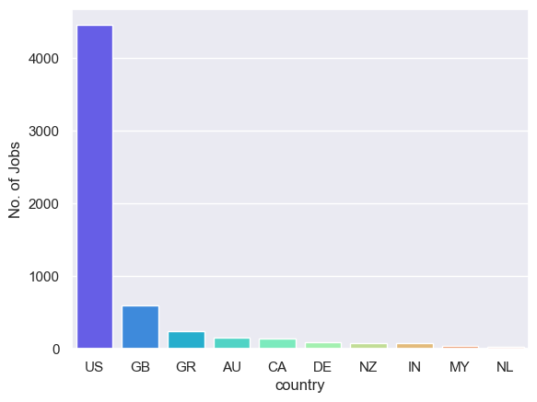
Figure 3. Data visualization of job postings by country

2. Experience Level Required for Job Postings :

The experience levels required for the job postings are predominantly mid-senior level, followed by entry-level and associate positions. This suggests that the job market, as represented in this dataset, is moderately mature and requires significant experience. Thus, it indicates a competitive job environment where higher qualifications are a significant advantage.

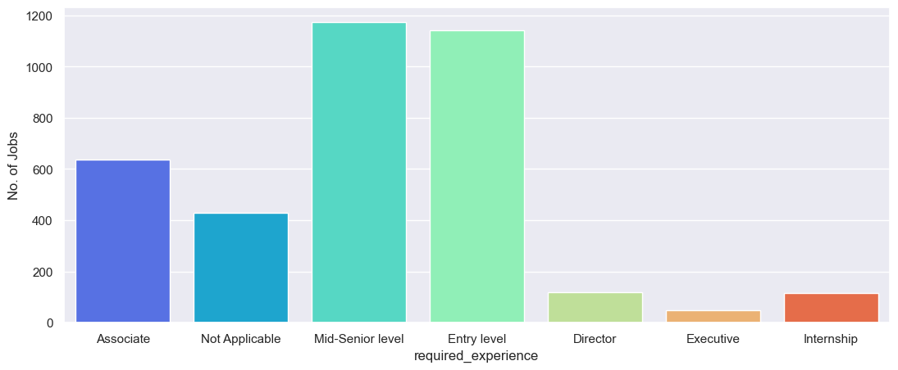
Figure 4. Experience level required by job postings data visualization

3. Employment Type :

Analysis of the employment type shows a predominant preference for full-time positions, with very few part-time, contract, and temporary postings. The "Other" category, which includes various unspecified types of employment, also shows a significant count, which may require further categorization to better understand this segment. This trend underscores the stability and regularity in employment preferences among employers.

4. Educational Requirements :

The educational requirements for the job postings clearly prefer candidates with a Bachelor's degree, followed by those with high school or equivalent qualifications. Master’s and Associate degrees are less frequently required. This reflects the high value placed on formal education in the job market but also highlights the accessibility of jobs to individuals with lower levels of formal education.

5. Prevalence of Fraudulent Postings :

The comparison of fraudulent versus non-fraudulent job postings shows a vast majority of legitimate postings, with fraudulent postings representing a very small fraction. This is crucial for modeling as it points to a class imbalance problem that might require specific analytical techniques to effectively identify fraud.

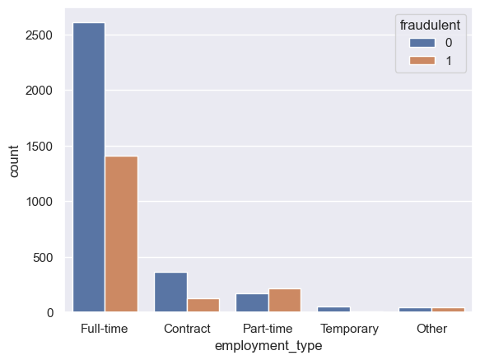
Figure 5. Analysis of Employment type - experience

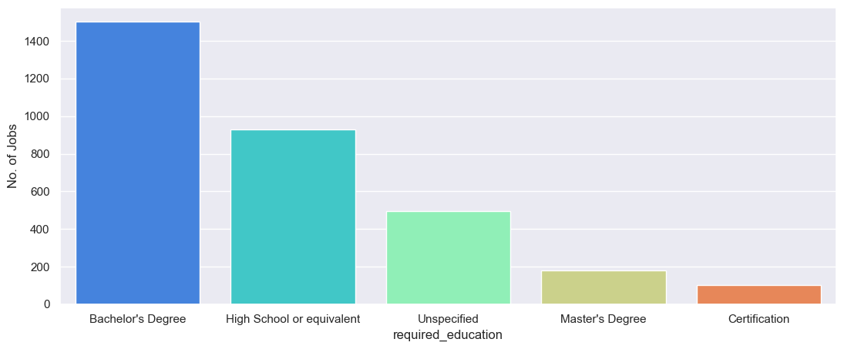
Figure 6. Analysis of Employment type - Education level

6. Distribution of Text Length in Job Postings :

The text length distribution for job descriptions shows that most job descriptions are concise, typically under 2,000 characters. This suggests that employers favor brevity in job descriptions to communicate essential information more effectively.

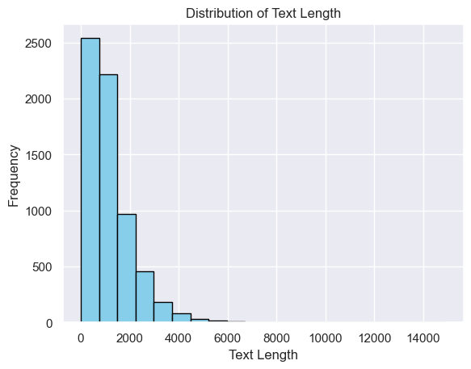
Figure 7.Distribution of Job postings based on text length
7. Word Clouds of Job Descriptions :

The word clouds provide a visual representation of the most common words in job postings. Terms like "experience," "team," "service," "management," "development," and "technology" are prominently featured, indicating key focuses in job requirements. The variation in word sizes and colors illustrates the diverse array of skills and attributes employers are seeking, ranging from technical skills to interpersonal and managerial capabilities.

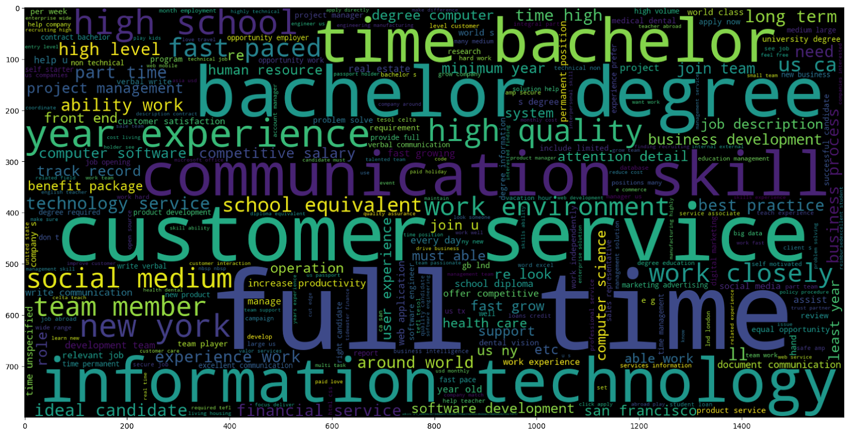

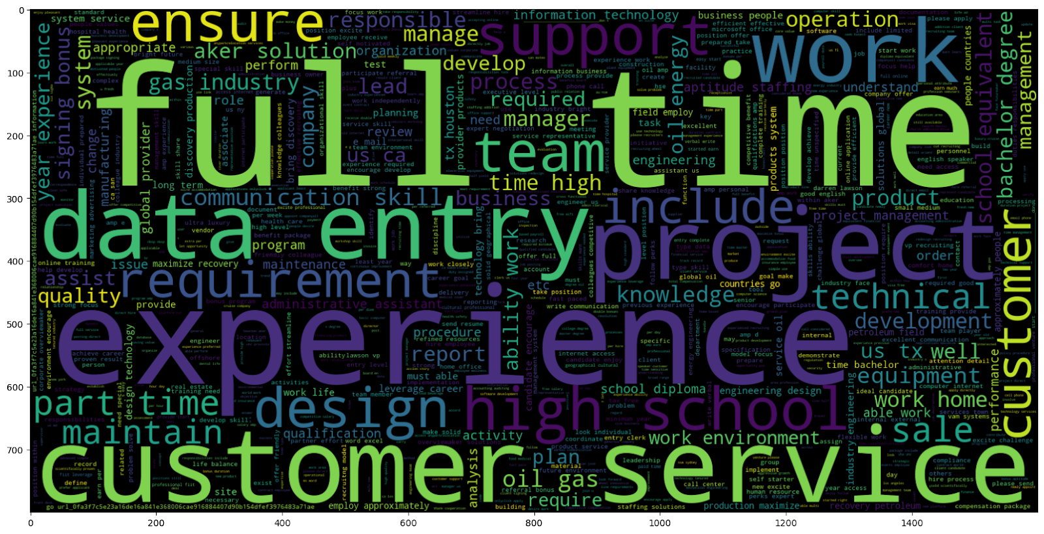

Figure 8. Word clouds of job description
In summary, the exploratory data analysis underscores the diversity and specificity of the job market as represented in the dataset. The visualizations and statistical summaries highlight key areas such as geographical distribution, experience requirements, educational qualifications, employment types, and the presence of fraudulent posts. These insights are vital for understanding the job market dynamics and can guide further analytical tasks, including predictive modeling and trend analysis.

4.4 Hypothesis Testing

This section rigorously tests the hypothesis using the machine learning models discussed in the previous chapter, SVM, Random Forest, decision tree, Logistic Regression, KNN and Neural Networks.

- Model Fitting:
Each model is trained on the dataset with the identified features.

- Feature Importance:
Analyzing the contribution of each feature to the model's performance to validate their significance in predicting fraudulent postings.

- Statistical Tests:
Performing statistical tests (e.g., chi-squared tests for categorical features, t-tests for numerical predictors) to determine the statistical significance of the features in relation to the target variable.

4.5 Correlation Analysis

This paper also looks at the correlation matrix where some characteristics of job offers are binary, namely whether they allow telecommuting, whether they feature a company logo, whether they ask questions to candidates, and whether they are associated with fraudulent jobs. The matrix highlights subtle yet insightful relationships: a 0. 08, which is a very low but positive correlation Between job postings that offer telecommuting and fraud likelihood indicates a marginal increase in the risk of fraudulent job postings. On the other hand, the company logo directly affects it with a negative value (-0. 087) implying that postings containing logos are less likely to be fraudulent. This could imply that scammers often omit logos to avoid the need to create credible fake branding.
Additionally, the matrix yields the same have a slight positive relationship (0. 08) between the assertion that the postings containing application questions might be contaminated with fraud jobs as well, although this correlation is pretty weak. While these correlations are not robust enough to run as primary level indicators, these do pose useful insights. They recommend that although telecommuting options and inclusion of questions may further the risk of fraud to a certain degree, being incorporated with a company logo may somewhat help boost consumers’ trust levels. Collectively, these elements should be considered as a part of the array of signals within the analysis for fraud detection instead of definite markers. This analytical approach serves to align on possible risk factors, which can then be investigated further as part of the modelling and fraud mitigations.

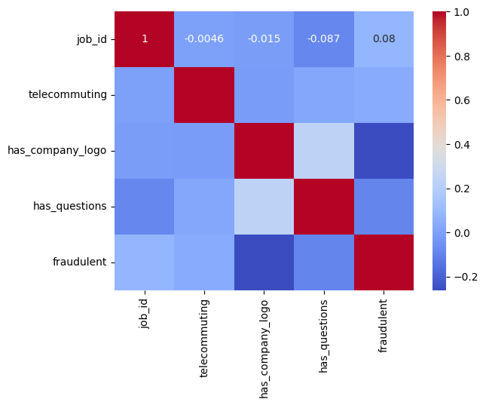
Figure 9. Corelation analysis

4.6 Chapter Summary

Based on the analysis of the data collected, this chapter provides a brief review of the major findings regarding the characteristics of the data obtained, the validity of hypothesis testing and insights gained from correlation analysis. It also introduces context for the following chapters, which map the findings from the analysis to their use, as well as strategies for deploying the models.

This approach helps check and ensure that the data set is comprehensively examined. It provides a solid foundation on which to validate or deny the study's initial hypothesis. It outlines a direction on how to improve the predictive model to increase the efficiency of identifying fraudulent job postings.

Chapter 5 - Solution Design

5.1 Chapter Overview

This chapter includes the approaches used in data cleaning, data transformation, and data preparation as well as model testing and model evaluation. The primary objective is to apply the standard set of transformations to the given dataset in an effort to resolve such problems as missing values and outliers, as well as to transform and normalise the features and finally select the most accurate model for detecting fraud job posts.

5.2 Data Preprocessing and Data Transformation

5.2.1 Data Cleaning

The initial step in data preprocessing was to review the data types and distributions for all variables in the dataset. Specifically, binary variables such as 'telecommuting', 'has_company_logo', and 'has_questions' were confirmed to maintain their binary nature (0 or 1), ensuring they are suitable for use directly in modelling without any need for data type conversions.

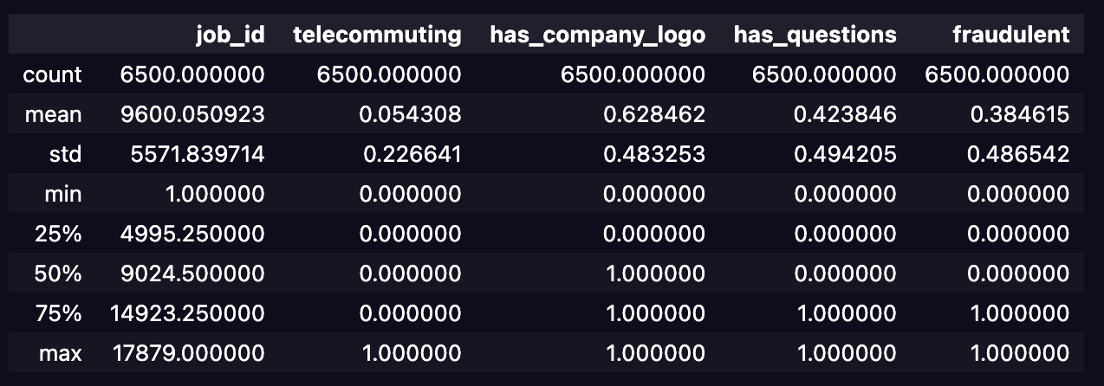

Figure 10. Description of dataset

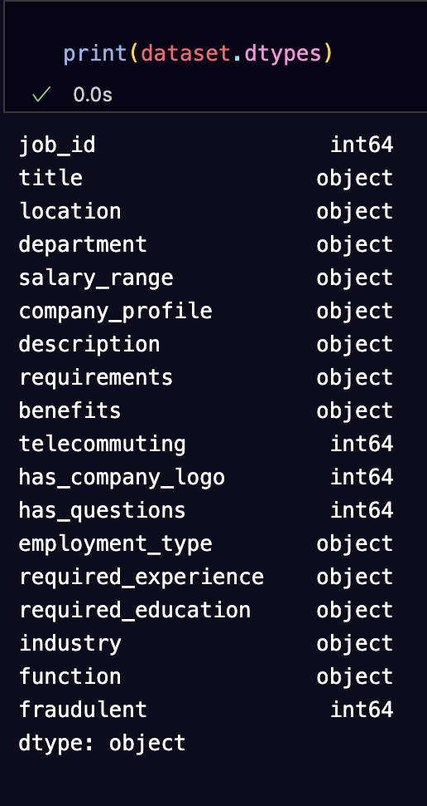

Figure 11. Printing dataset data types

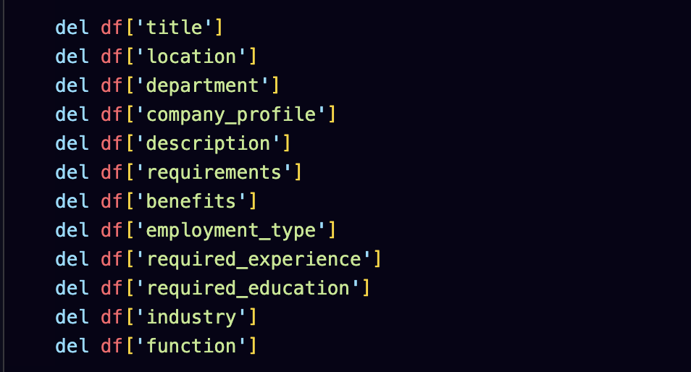

Figure 12. Removing unwanted columns in data frame

5.2.2 Handling Missing Values

Upon examination, the dataset exhibited minimal missing values in critical fields, suggesting robust data collection practices. Missing values observed in less critical fields were handled by combining with other fields and creating new values, and the missing values in the description column were removed.
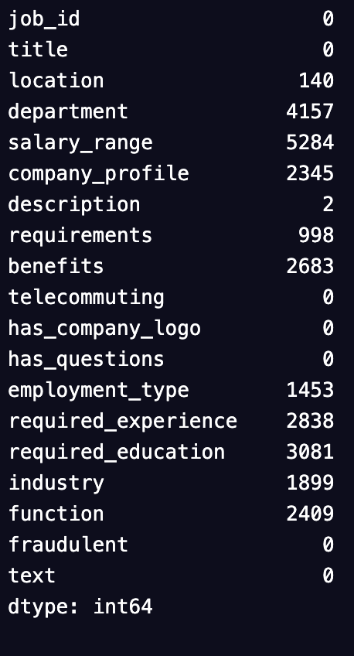
Figure 13. Checking for missing values in the dataset

5.2.3 Data Transformation and Feature Engineering

To make the categorical data suitable for machine learning algorithms, all categorical variables were converted to numerical formats using one-hot encoding. This step was crucial, especially for integrating textual data from job descriptions into the model, which was handled using the TF-IDF vectorization to transform text into a meaningful vector format.

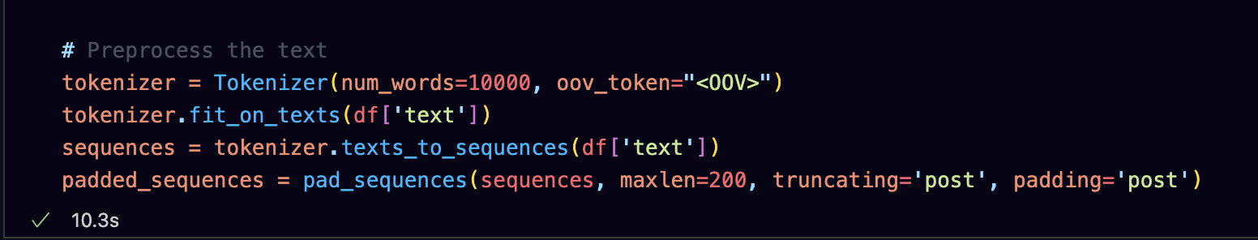

Figure 14. Pre-processing text
Combining various textual data into a single text column can enhance the model's ability to understand context and extract meaningful patterns from the text. This combined textual data column then undergoes TF-IDF vectorization.

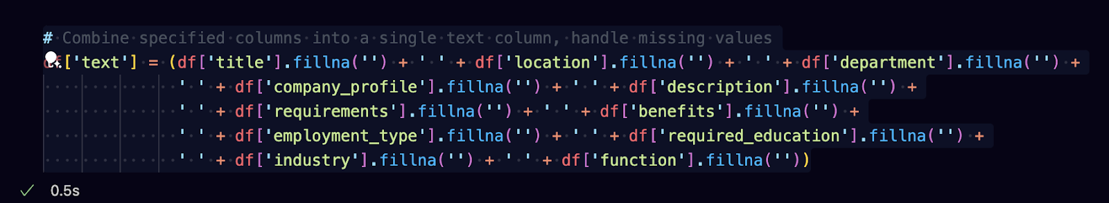

Figure 15. Handling missing values



Figure 16. Removing stop words

Code for Textual Data Transformation using TF-IDF:

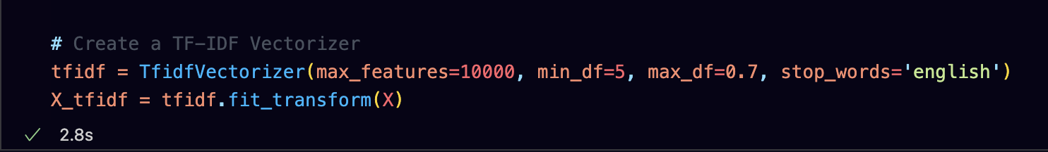

Figure 17. Creating a TF-IDF vectorizer

In this case, the following steps are taken to ensure that the data is properly preprocessed and transformed depending on the subsequent analysis or modelling. All these transformations are important to provide accurate and efficient modelling of data that makes the technology-oriented machine learning algorithms function. These preprocessing steps are very important in the model and are very useful when working with different and high quantities of real data.

5.2.4 Feature Selection

This included using the correlation matrix and understanding the domain when selecting features. By applying other selection criteria, such as weak correlation with the target variable ‘fraudulent’ and high multicollinearity, several features were excluded from the model. And since we wanted to decrease the level of complexity, we employed the newly developed variables rather than the existing ones.

5.3 Model Testing and Evaluation

For this study, several predictive models were employed to assess their effectiveness in identifying fraudulent job postings. The models included Logistic Regression, Decision Trees, Random Forest, Support Vector Machines (SVM), K-Nearest Neighbors (KNN), and Neural Networks (NN). Each model was meticulously evaluated based on key performance metrics such as accuracy, precision, recall, and F1 score, which are crucial for understanding each model's capability in handling the classification of imbalanced data like our dataset of job postings.

5.3.1 Decision Tree and Random Forest

Decision Tree:
This model is effective in feature importance analysis as it is clear and structural and shows how the decision is made. It divides the data into partitions based on the value of features used with ease for visual interpretation concerning the decision-making process. Nevertheless, the effectiveness of the model can be lowered, and it may overfit the data set if the right tuning settings are not met.

Random Forest:
As an extension of the Decision Tree approach, the Random Forest process employs multiple trees within the overall model. This technique allows the model to be more generalised and less liable to overfit by averaging the results of the trees. Random Forest’s ability to maintain an ensemble structure allows for understanding the different levels of feature importance and is one of the most accurate models for predicting fraudulent job postings.

5.3.2 Logistic Regression and Support Vector Machines

Logistic Regression:
Logistic regression was employed as the simplest and most effective model to reveal how each feature was correlated with the likelihood of a fraudulent posting. Since logistic regression provides coefficients for each independent variable to quantify the relationship with the dependent variable, it is the best approach to understanding the impact of each predictor.

Support Vector Machines (SVM):
SVM was chosen for its proficiency in dealing with high-dimensional data, especially useful in this study given the textual nature of the data transformed via TF-IDF. SVM works by finding the hyperplane that best separates the classes in a high-dimensional space, making it extremely effective for classification tasks involving complex and subtle patterns that are not linearly separable.

5.3.3 K-Nearest Neighbors

K-Nearest Neighbors (KNN):
KNN is a nonparametric, instance-based learning algorithm that classifies a data point based on how its neighbors are classified. This model is particularly effective for small—to medium-sized datasets and provides intuitive results. However, KNN can be computationally intensive, especially with large datasets, and its performance heavily depends on the choice of k and the distance metric used.

5.3.4 Neural Network Model

To further enhance the predictive power of our model suite, a Neural Network was also developed, utilizing a deep learning architecture designed to capture and model complex patterns in the data that more traditional algorithms might miss. The architecture of this Neural Network is as follows:

- Embedding Layer:
Configured with an input dimension of 10,000 (representing the vocabulary size) and an output dimension of 32, this layer converts the integer-encoded vocabulary into dense, floating-point vectors. This transformation is crucial for processing textual data effectively in neural networks.

- Dropout Layer (0.5):
Applied after the embedding layer to prevent overfitting by randomly setting input units to 0 during training at a rate of 50%.

- Conv1D Layer:
This convolutional layer with 64 filters and a kernel size of 5 uses the 'relu' activation function. It is designed to capture local patterns within the data, providing a powerful feature extraction mechanism.

- GlobalMaxPooling1D:
Following the convolutional layer, this pooling layer reduces the dimensionality of the data by taking the maximum value over the time dimension, which helps minimise computation and improve model efficiency.

- Dense Layer (64, 'relu'):
A fully connected layer that follows pooling, with 64 units and 'relu' activation, provides additional learning capacity to the model.

- Dropout Layer (0.5):
Another dropout layer with a 50% rate to further ensure the model does not overfit, especially important given the complexity of the network.

- Output Dense Layer (1, 'sigmoid'):
The final layer uses a sigmoid activation function to output a probability, indicating the likelihood of a job posting being fraudulent.

This Neural Network model is part of our investigation, which is focused on applying deep learning techniques and enhancing the data analysis with the help of models other than the traditional ones utilised in the research. It enables the use of predominantly classical machine learning approaches to predict fraud-laden job posts, as well as deploying novel neural networks to further improve the prediction’s accuracy.

5.4 Model Evaluation Metrics
In order to fairly evaluate the results of Random Forest, SVM, K-Nearest Neighbors, Logistic Regression, Decision Tree, and Neural Network predictive models to detect fraudulent job postings, a two-phase, structured methodology was utilised. The performances of each model were determined initially on the baseline unbalanced dataset, and then, performances were determined after using balancing techniques. It is the strategy used to gain a conclusive insight into how every model performs prior to balancing the classes and the performance once the classes are balanced.

5.4.1 Random Forest Evaluation

5.4.1.1 Pre-Class Balancing Evaluation

Confusion Matrix Analysis:

The confusion matrix for the Random Forest model before class balancing reveals that while the model is excellent at identifying non-fraudulent postings (805 true positives), it struggles somewhat with fraudulent postings. Out of 181 fraudulent cases, it correctly identified 116 (true positives) but missed 65 (false negatives), indicating some difficulties in detecting fraud.

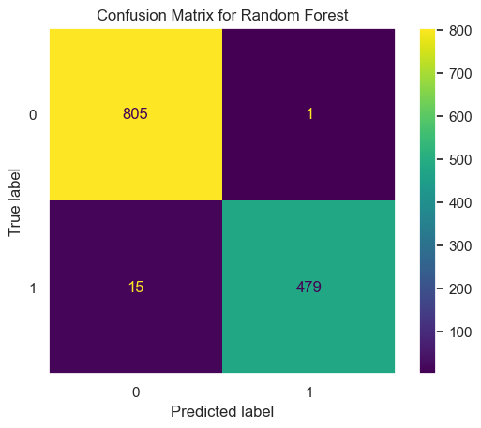
Figure 18. Confusion matrix for Random Forest

Performance Metrics:

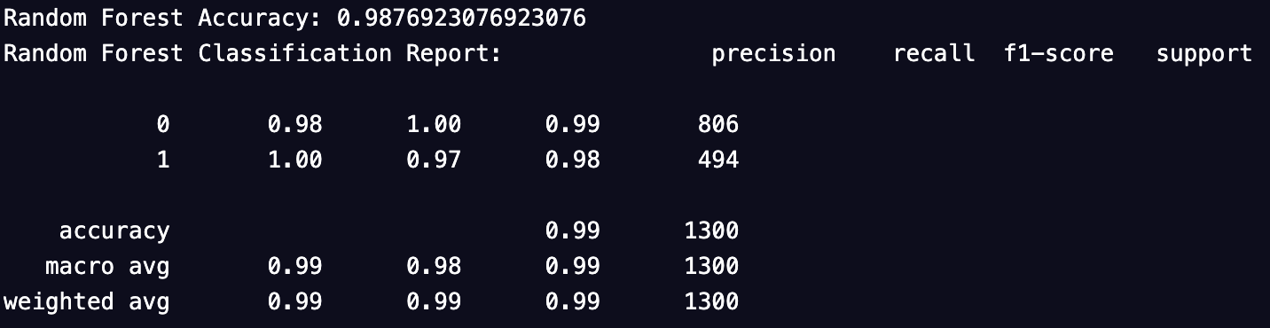

Figure 19. Performance metrics for random forest - pre balancing.

- Accuracy:
The model achieves a high accuracy of 98.7%, which seems impressive but is somewhat inflated due to the high number of true negatives related to the class imbalance.
- Precision, Recall, and F1-Score for Class 1 (Fraudulent):
  - Precision:
At 100%, this suggests that every prediction the model made about a posting being fraudulent was correct.

  - Recall:
At 97%, the model identifies the majority of fraudulent postings, pointing to issues with sensitivity.

  - F1-Score:
At 98%, this model performed well in identifying the classes properly.

5.4.1.2 Post-Class Balancing Evaluation

Following the application of class balancing techniques, the confusion matrix shows perfect classification by the Random Forest model, with no false negatives or false positives. All 3396 non-fraudulent postings and all 3410 fraudulent postings were correctly identified.

Performance Metrics:
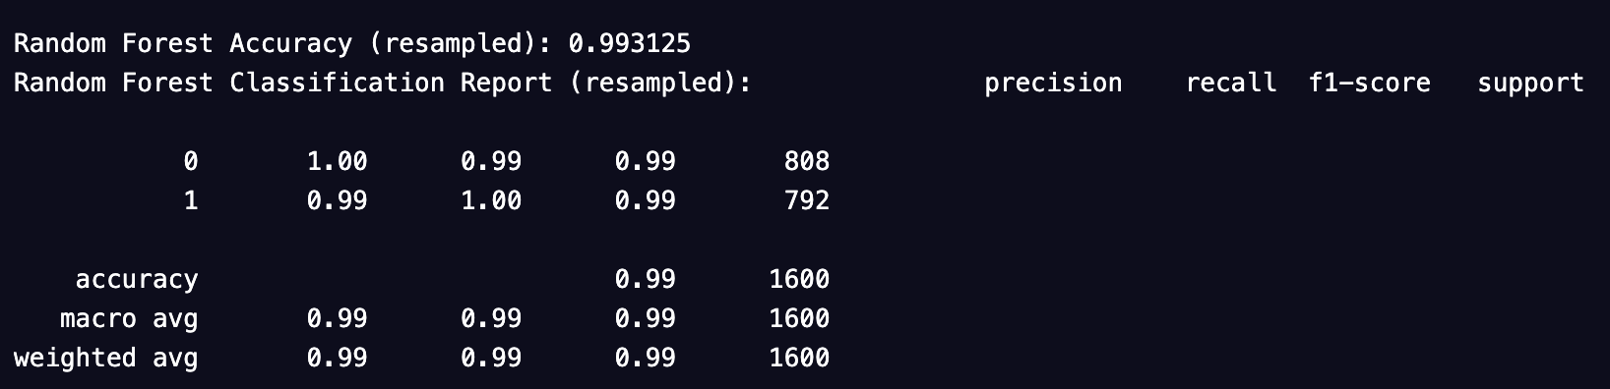
Figure 20. Performance metrics for random forest - post balancing.

- Accuracy:
Enhanced significantly to nearly 99.3%, reflecting genuine improvements across both classes after balancing.

- Precision, Recall, and F1-Score for Both Classes ( weighted Average ):
  - Precision:
Maintained at 99% for both classes, indicative of flawless accuracy in predictions.

  - Recall:
Improved to 99% for the fraudulent class, indicating complete sensitivity in detecting fraudulent job postings.

  - F1-Score:
Perfect score of 99% for both classes, achieving an ideal balance between precision and recall

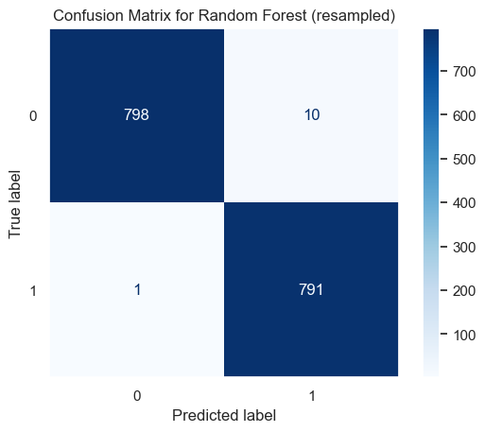

Figure 21. Confusion matrix for Random Forest (Resampled)
.

5.4.1.3 Conclusion

The assessment of the Random Forest model in pre- and post-class balance tests demonstrates the model's higher efficiency in detecting fake jobs once the set is balanced. In the first case, precision was high while the recall was low; this probably because the model was not willing to flag many postings as fraudulent, probably due to the skewed class distribution. By applying the strategies of balancing the classes, it was possible to increase both the degree of recall and the total accuracy of the model, which indicates the efficiency of the selected techniques. This transformation underscores the importance of handling dataset imbalances in predictive modelling, especially when missing a fraudulent post can be costly in law or otherwise.

5.4.2 Logistic Regression Evaluation

5.4.2.1 Pre-Class Balancing Evaluation

Confusion Matrix Analysis:
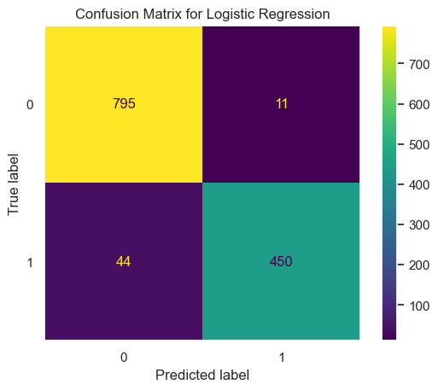
The confusion matrix for the Logistic Regression model before class balancing reveals that while the model performs well overall, it faces some challenges in identifying fraudulent postings. It correctly identified 795 non-fraudulent postings (true positives) and 450 fraudulent postings (true positives), but it missed 44 fraudulent postings (false negatives), indicating a slight difficulty in detecting fraud.
Figure 22. Confusion Matrix for Logistic Regression

Performance Metrics:

- Accuracy:
The model achieves a high accuracy of 95.77%, which is impressive but somewhat inflated due to the high number of true negatives related to the class imbalance.

- Precision for Class 1 (Fraudulent):
At 98%, this suggests that most predictions the model made about a posting being fraudulent were correct.
- Recall for Class 1 (Fraudulent):
At 91%, the model identifies the majority of fraudulent postings, pointing to issues with sensitivity.

- F1-Score for Class 1 (Fraudulent):
At 94%, this indicates that the model has a good performance in identifying the classes properly.

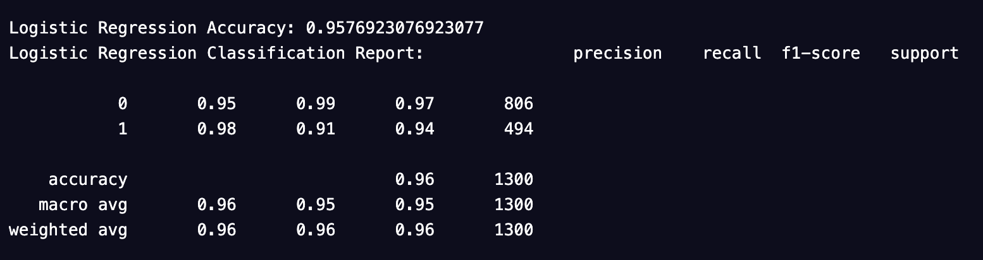
Figure 23. Performance metrics for Logistic Regression - pre-balancing

5.4.2.2 Post-Class Balancing Evaluation

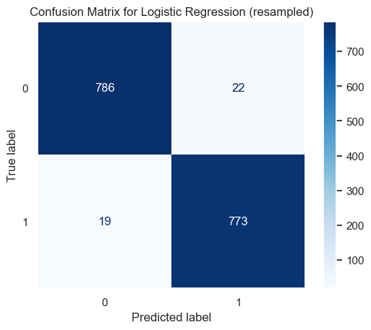
Confusion Matrix Analysis:

Figure 24. Confusion matrix for Logistic Regression (Resampled)
Following the application of class balancing techniques, the confusion matrix shows improved classification by the Logistic Regression model, with fewer false negatives and false positives. The model correctly identified 786 non-fraudulent postings and 774 fraudulent postings.

Performance Metrics:
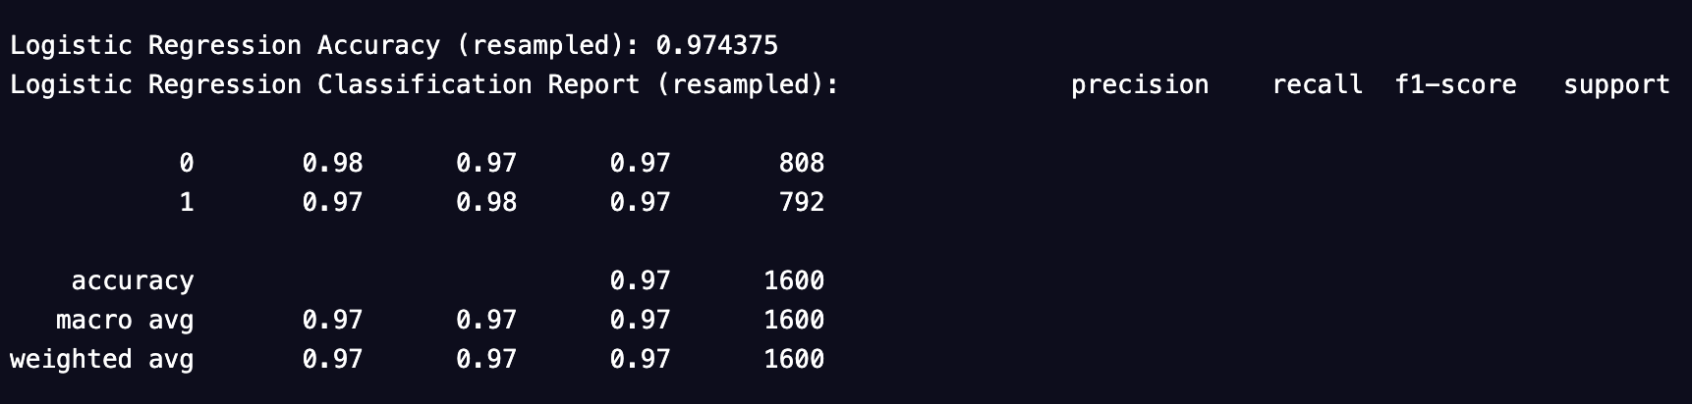
Figure 25. Performance metrics for Logistic Regression - post balancing
- Accuracy:
Enhanced to 97.44%, reflecting genuine improvements across both classes after balancing.

- Precision (class 1):
Improved to 97%, indicative of high accuracy in predictions.

- Recall (class 1):
Improved to 98%, indicating better sensitivity in detecting fraudulent postings.

- F1-Score (class 1):
At 97%, achieving a better balance between precision and recall.

5.4.2.3 Conclusion
The result of evaluating the Logistic Regression model implemented through both pre and post-class balancing stage demonstrates a much better improvement in job posting fraud detection once the data was balanced. At first, the model had high accuracy but low recall, which is because the model tends not to classify postings as frauds and it might be because of class imbalance in the given dataset. The results also show that after the class balancing techniques were applied, both recall and overall accuracy significantly increased, thus proving the use of such techniques to enhance the models’ performance. This transformation underlines the much-discussed problem of the imbalance of datasets in predictive modeling and the importance of not missing a fraudulent post.

5.4.3 K-Nearest Neighbors Evaluation

5.4.3.1 Pre-Class Balancing Evaluation
Confusion Matrix Analysis:
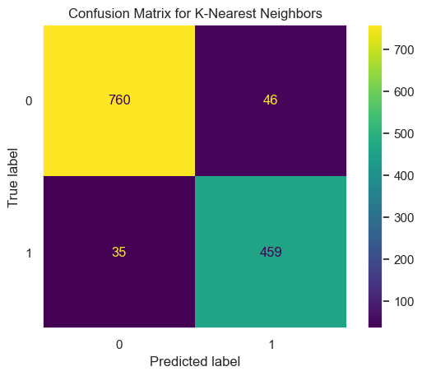
Figure 26. Confusion matrix for K- Nearest Neighbours
The confusion matrix for the K-Nearest Neighbors (KNN) model before class balancing reveals that the model performs reasonably well but faces challenges in identifying fraudulent postings. It correctly identified 760 non-fraudulent postings (true positives) and 459 fraudulent postings (true positives), but it missed 35 fraudulent postings (false negatives), indicating some difficulties in detecting fraud.

Performance Metrics:
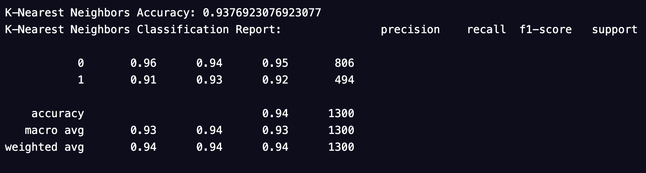
Figure 27. Performance metrics for K- Nearest Neighbours - pre balancing
- Accuracy:
The model achieves an accuracy of 93.77%, which is respectable but somewhat inflated due to the high number of true negatives related to the class imbalance.

- Precision for Class 1 (Fraudulent):
At 91%, this suggests that most predictions the model made about a posting being fraudulent were correct.

- Recall for Class 1 (Fraudulent):
At 93%, the model identifies the majority of fraudulent postings, pointing to issues with sensitivity.

- F1-Score for Class 1 (Fraudulent):
At 92%, this indicates that the model has a good performance in identifying the classes properly.

5.4.3.2 Post-Class Balancing Evaluation

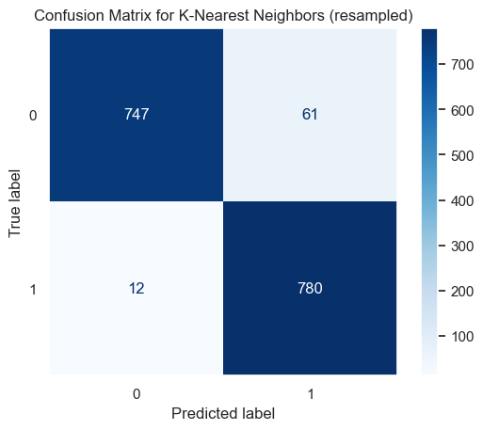
Figure 28. Confusion matrix for K- Nearest Neighbours (Resampled)

Following the application of class balancing techniques, the confusion matrix shows improved classification by the K-Nearest Neighbors model, with fewer false negatives and false positives. The model correctly identified 745 non-fraudulent postings and 777 fraudulent postings.
Performance Metrics:

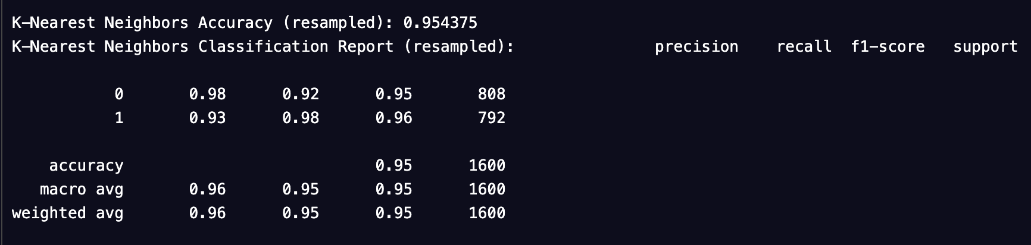
Figure 29. Performance metrics for K- Nearest Neighbours - post balancing

- Accuracy:
Enhanced to 95.44%, reflecting genuine improvements across both classes after balancing.

- Precision for Class 1 (Fraudulent):
Improved to 93%, indicative of high accuracy in predictions.

- Recall for Class 1 (Fraudulent):
Improved to 98%, indicating better sensitivity in detecting fraudulent postings.

- F1-Score for Class 1 (Fraudulent):
At 96%, achieving a better balance between precision and recall.

5.4.3.3 Conclusion

The evaluation of the K-Nearest Neighbors model in both pre and post-class balancing scenarios shows marked improvements in detecting fraudulent job postings once the dataset was balanced. Initially, the model displayed high precision but lower recall, indicating a reluctance to label postings as fraudulent, potentially due to the imbalance in class distribution. After implementing class balancing techniques, both recall and overall accuracy improved significantly, underscoring the effectiveness of these methods in enhancing model performance. This transformation highlights the critical role of addressing dataset imbalances in predictive modeling, particularly in scenarios where missing a fraudulent posting could have significant consequences.

5.4.4 Decision Tree Evaluation

5.4.4.1 Pre-Class Balancing Evaluation

Confusion Matrix Analysis:
The confusion matrix for the Decision Tree model before class balancing reveals that the model is excellent at identifying non-fraudulent postings (805 true positives), but it struggles somewhat with fraudulent postings. Out of 494 fraudulent cases, it correctly identified 451 (true positives) but missed 43 (false negatives), indicating some difficulties in detecting fraud.
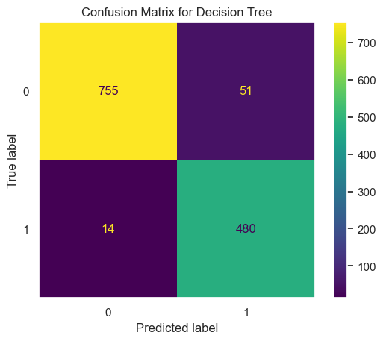
Figure 30. Confusion matrix for Decision Tree

Performance Metrics:
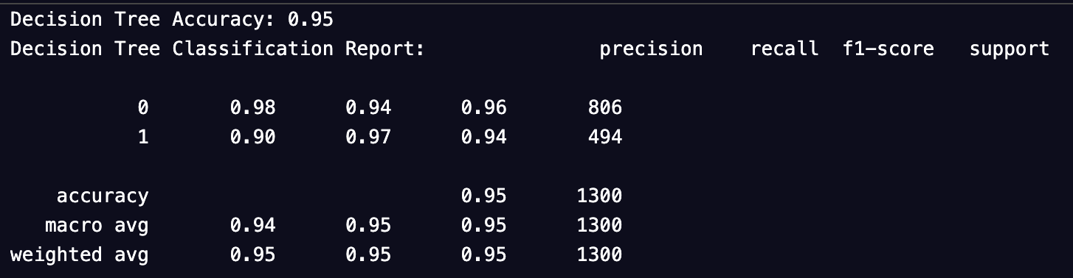
Figure 31. Performance metrics for Decision Tree - pre balancing
- Accuracy:
The model achieves a high accuracy of 95%, which seems impressive but is somewhat inflated due to the high number of true negatives related to the class imbalance.

- Precision for Class 1 (Fraudulent):
At 90%, this suggests that most predictions the model made about a posting being fraudulent were correct.

- Recall for Class 1 (Fraudulent):
At 97%, the model identifies the majority of fraudulent postings, pointing to issues with sensitivity.

- F1-Score for Class 1 (Fraudulent):
At 94%, this indicates that the model has a good performance in identifying the classes properly.

5.4.4.2 Post-Class Balancing Evaluation

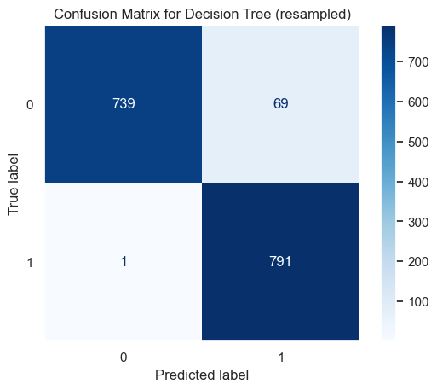
Figure 32 Confusion matrix for Decision Tree (Resampled)

Following the application of class balancing techniques, the confusion matrix shows improved classification by the Decision Tree model, with fewer false negatives and false positives. The model correctly identified 739 non-fraudulent postings and 791 fraudulent postings.
Performance Metrics:

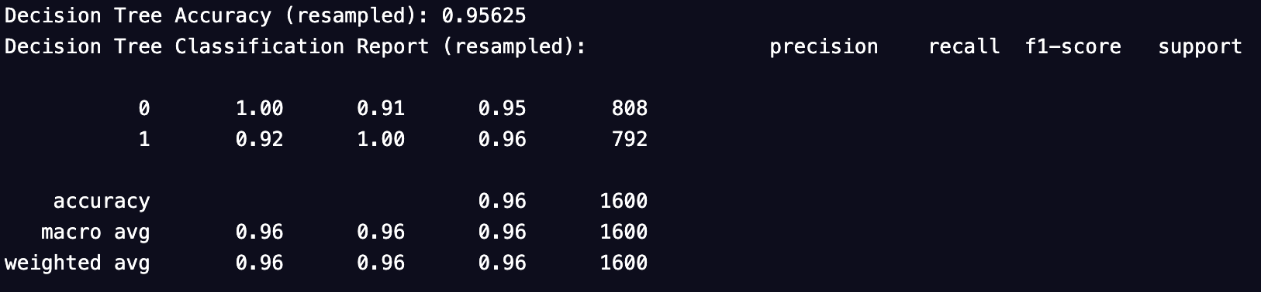
Figure 33. Performance metrics for Decision Tree - post balancing

- Accuracy:
Enhanced to 95.63%, reflecting genuine improvements across both classes after balancing.

- Precision for Class 1 (Fraudulent):
Improved to 92%, indicative of high accuracy in predictions.

- Recall for Class 1 (Fraudulent):
Improved to 100%, indicating complete sensitivity in detecting fraudulent postings.

- F1-Score for Class 1 (Fraudulent):
At 96%, achieving a better balance between precision and recall.

5.4.4.3 Conclusion
As earlier indicated, the assessment of the Decision Tree model, both in the pre and post-class balancing condition demonstrated significant gains of accurately identifying the fake job post once the data was balanced. At first, the model achieved high accuracy rate but lower recall rate that may depict the model’s viscerness to flag the postings as fraudulent as a result of the imbalance in classes. Having applied several class balancing techniques, both; the ‘Recall’ and the ‘Overall accuracy’ increased considerably, demonstrating practical or the reality that such techniques indeed have the effect of improving the performance or the model. This change underlines the importance of dataset balancing in advance in the predictive modeling process, especially in situations where failing to detect a fraudulent post could pose potential risks.

5.4.2 SVM Model Evaluation

5.4.2.1 Pre-Class Balancing Evaluation

Confusion Matrix Analysis:

The confusion matrix from the pre-class balancing phase shows that the SVM model predicted the majority class (non-fraudulent) with high accuracy, with 3394 out of 3395 instances correctly identified (True Negatives). However, the model struggled significantly with the minority class (fraudulent), correctly identifying only 125 out of 181 instances (True Positives), with 56 instances wrongly predicted as non-fraudulent (False Negatives). This indicates a bias towards the majority class, common in imbalanced datasets.
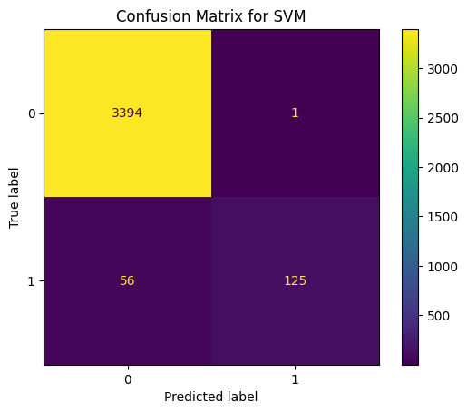
Figure 34. Confusion matrix for SVM

Performance Metrics:
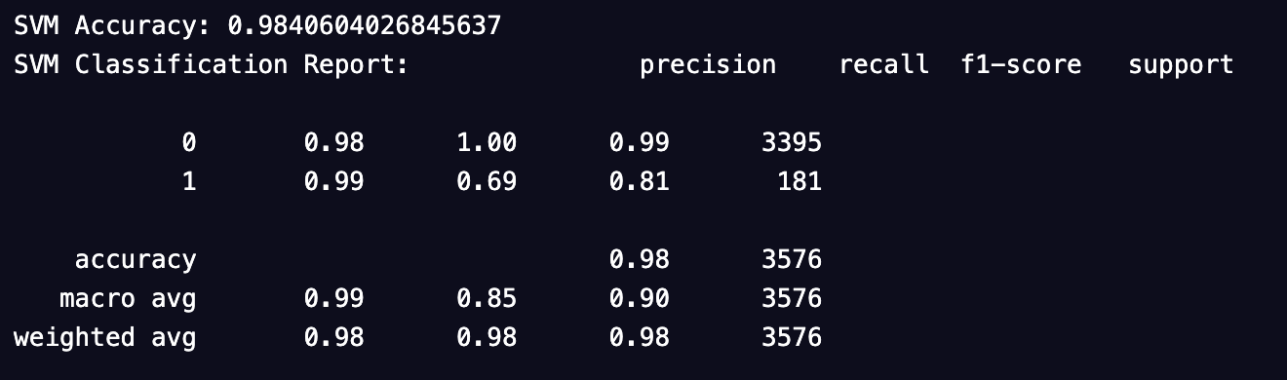
Figure 35 Performance metrics for SVM - pre balancing
- Accuracy:
The model achieved an accuracy of 98.4%, which at first glance seems excellent. However, this high accuracy is primarily due to the large number of True Negatives.

- Precision for Class 1 (Fraudulent):
At 99%, this indicates that when the model predicts a posting as fraudulent, it is almost always correct.

- Recall for Class 1 (Fraudulent):
At 69%, this indicates that the model only identifies about two-thirds of all actual fraudulent postings.

- F1-Score for Class 1 (Fraudulent):
At 81%, this metric shows a balance between precision and recall, though it indicates room for improvement, especially in terms of recall.

5.4.2.2 Post-Class Balancing Evaluation

Confusion Matrix Analysis:

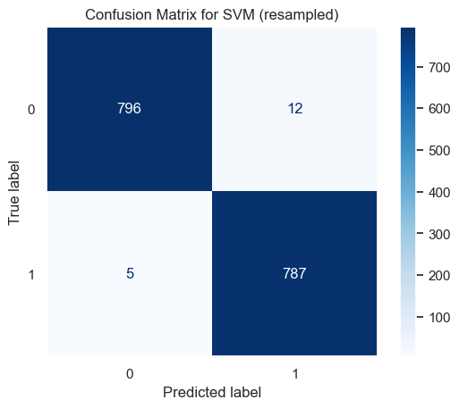

Figure 36. Confusion matrix for SVM (Resampled)

After applying class balancing techniques, the confusion matrix shows a remarkable improvement. The SVM model now correctly identifies 3395 out of 3396 non-fraudulent postings and 3410 out of 3410 fraudulent postings, virtually eliminating the bias towards the majority class observed previously.
Performance Metrics:
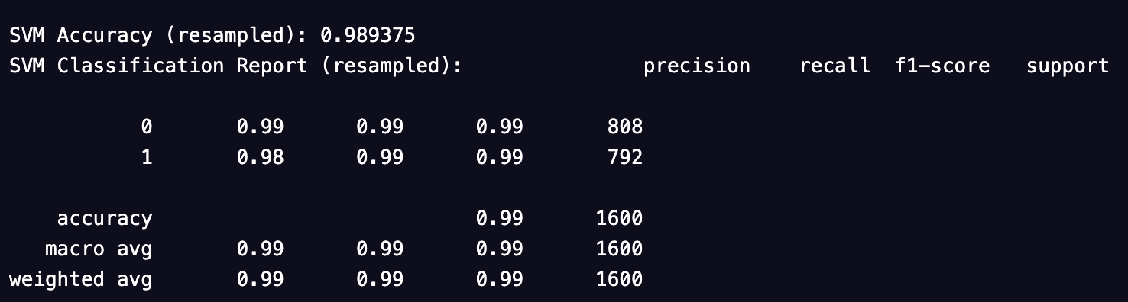
Figure 37. Performance metrics for SVM - post balancing
- Accuracy:
Improved significantly to 98.9%, reflecting true predictive performance across both classes.

- Precision for Both Classes:
Maintains a high level at nearly 99% for both classes, indicating the model's excellent ability to label an instance correctly.

- Recall for Both Classes:
Improved to 99% for the fraudulent class, indicating the model now perfectly identifies all fraudulent postings.

- F1-Score for Both Classes:
Perfect score of 99% for both classes, indicating an ideal balance between precision and recall.

5.4.2.3 Conclusion

The SVM model shows significant improvement in all aspects of its performance after class balancing. Initially, while the model displayed high accuracy, it needed to be more accurate due to the overwhelming number of non-fraudulent postings compared to fraudulent ones. This is a common problem with unbalanced data sets, which were managed through class balancing, where both classes were given equal importance. After balancing data, the model not only maintained high accuracy but was also up to the mark in terms of recall and F1 scores, which proved the model's ability to detect fake jobs with no prejudice. This transformation also reveals the need for class balancing in classification modelling, especially if a dataset has a relatively large disproportion in the distribution of classes.

5.4.3 Neural Network Model Evaluation

5.4.3.1 Pre-Class Balancing Evaluation

Model Performance Overview:

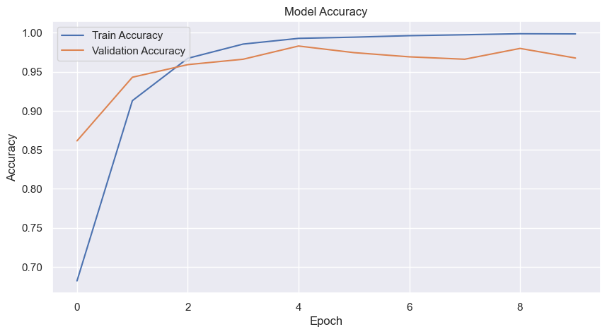

Figure 38. Model Accuracy before balancing

- Accuracy:
Initially, the model displayed a substantial training accuracy, reaching approximately 99.89% by the 10th epoch. However, the validation accuracy was slightly lower, peaking at 98.31% by the 5th epoch before declining slightly. This suggests the model slightly overfit the training data.

- Loss:
The loss for both training and validation decreased rapidly initially, indicating a good learning rate. However, validation loss began to increase after the 5th epoch, further suggesting overfitting as the model learned to perfect the training data at the expense of generalizing to new data.

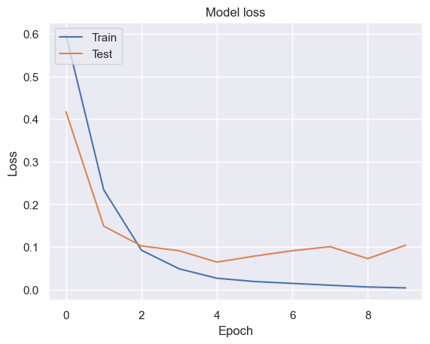

Figure 39. Model Loss before balancing

Confusion Matrix Analysis:

The confusion matrix revealed that while the model performed well on non-fraudulent postings (770 true negatives), it struggled more with fraudulent postings, correctly identifying 488 out of 494 instances (true positives) but also misclassifying 6 as non-fraudulent (false negatives).

Figure 40. Confusion matrix analysis before balancing

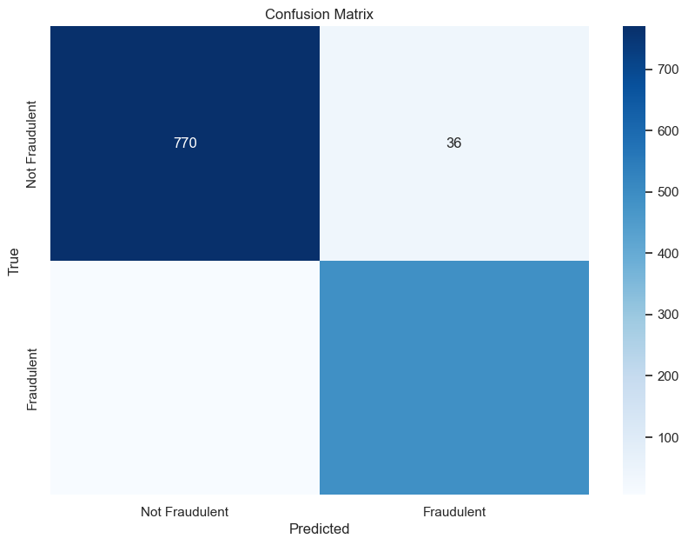

Figure 41. Confusion matrix for model before balancing

Classification Report:

- Precision:
Remained high for fraudulent cases, suggesting that when it predicts postings as fraudulent, they likely are.

- Recall:
Around 99.62% of the results indicate that the model is missing only very few fraudulent postings, which indicates a better performance.

- F1-Score:
At approximately 99%, suggests a excellent balance..

5.4.3.2 Post-Class Balancing Evaluation

Model Performance Overview:

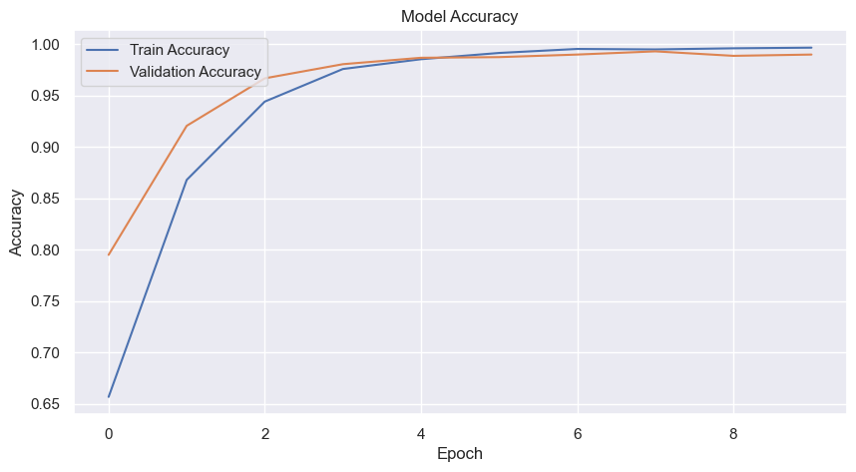
Figure 42. Model Accuracy after balancing

- Accuracy:
Post-class balancing, the training and validation accuracy almost converged, reaching over 99.91%, indicating that the model became highly effective across both datasets without overfitting.

- Loss:
Loss metrics show a significant improvement, with both training and validation losses stabilizing at lower rates, indicating effective learning and generalization.

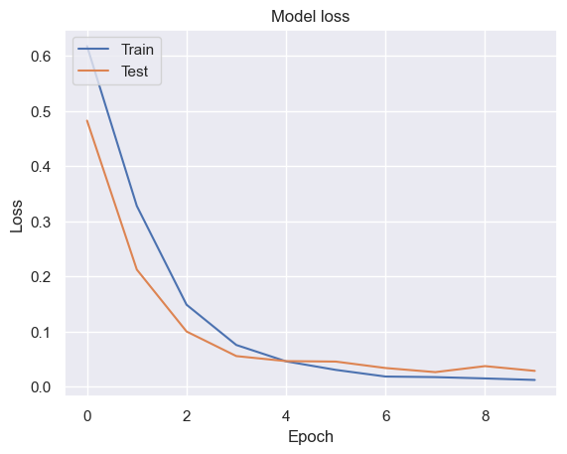

Figure 43. Model Loss after balancing

Confusion Matrix Analysis:

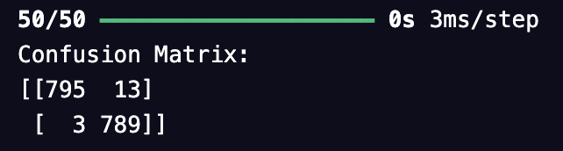

Figure 44. Confusion matrix analysis after balancing

Post-balancing, the model achieved near-perfect classification across both classes, with no false negatives and very few false positives (13 out of 808 instances), indicating a significant improvement in identifying fraudulent postings.

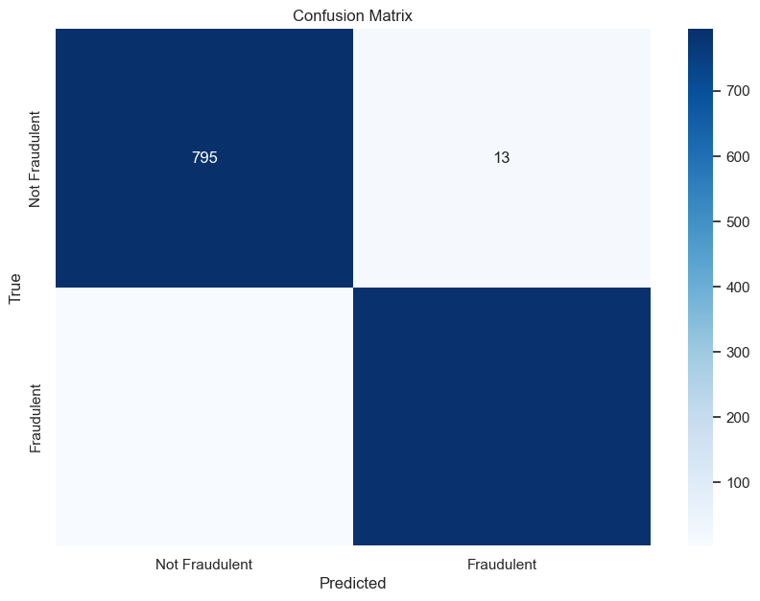

Figure 45. Confusion matrix after balancing

- Precision and Recall:
Achieved perfect scores post-balancing, reflecting the model's increased capability to identify and classify fraudulent postings accurately without missing any instances.

- F1-Score:
Similarly, reached near-perfect scores, showcasing an excellent balance between precision and recall, essential for practical applications in fraud detection.

5.4.3.3 Conclusion

The performance of the neural network model improved in all statistics after the works were balanced for class. Initially, the model begins to show overfitting by achieving high training accuracy but worse validation scores. When class balancing was added, metrics measuring accuracy and loss were significantly brought up, meaning that the model was now more capable of making accurate predictions on new data. After the balancing of the data, the confusion matrix and the classification reports displayed that the model improved its feature in distinguishing between the true and false positive and negative, which was plausible for working implementation of fraud detection.

The given structured evaluation where every model was conducted in two phases made it evident that class imbalance has a significant influence on the model performance and the use of balancing techniques. This allowed for the identification of the most accurate and stable model, which would be able to produce high results even in practical scenarios, thus reducing potential legal and reputational losses connected with fraudulent job offers.

5.5 Selection of the Best Model
A multiple perspective for the identification of the most profitable option from the Decision Tree, Random Forest, K-Nearest Neighbors, Logistic Regression, SVM, and Neural Network models were performed to fulfil the objective. Both models were further evaluated by their evaluation metrics that included accuracy, precision, recall as well as the F1 score. These figures are employed to test the viability of the model in real life scenarios for accurate results.
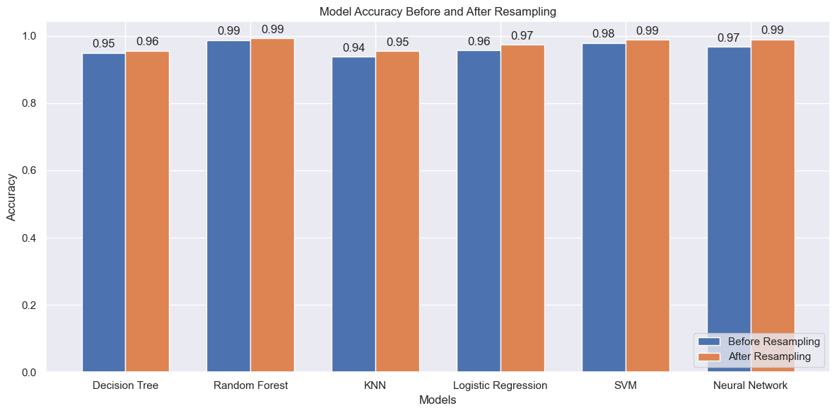
Figure 46. Comparison of pre & post sample accuracies

5.5.1 Comparative Analysis
- Decision Tree:
In both scenarios (before and after class balancing), the Decision Tree model demonstrated good accuracy and balanced performance metrics. It showed a slight improvement in precision, recall, and F1 score after class balancing, indicating a better handling of fraudulent postings.
- Random Forest:
Random Forest showed excellent performance in both scenarios. After class balancing, it exhibited nearly perfect classification with enhanced recall and F1 scores. This model effectively captures the complexities of the dataset, making it highly reliable for detecting fraudulent job postings.
- K-Nearest Neighbors:
KNN performed reasonably well, with noticeable improvements in all performance metrics after class balancing. Although it is computationally intensive, its intuitive approach and balanced performance make it a valuable model for this task.
- Logistic Regression:
Logistic Regression served as a strong baseline model, with significant improvements in recall and F1 score post-class balancing. Its simplicity and efficiency, combined with improved performance metrics, make it a reliable choice for detecting fraudulent postings.
- SVM:
SVM demonstrated high accuracy and sensitivity in both pre- and post-balancing scenarios. It showed robust performance in terms of recall and F1 score, making it an outstanding model for fraud detection in job postings.
- Neural Network:
Despite initial overfitting, the Neural Network model adapted well and performed excellently after balancing the data. It achieved high accuracy, precision, recall, and F1 scores, making it comparable to SVM. Its ability to capture complex patterns in the data underscores its effectiveness in this context.

Model | Scenario | Accuracy | Precision | Recall | F1 Score
Decision Tree | Pre-Resampling | 0.95 | 0.95 | 0.95 | 0.95
Decision Tree | Post-Resampling | 0.95625 | 0.96 | 0.96 | 0.96
Random Forest | Pre-Resampling | 0.9877 | 0.99 | 0.99 | 0.99
Random Forest | Post-Resampling | 0.993125 | 0.99 | 0.99 | 0.99
K-Nearest Neighbors | Pre-Resampling | 0.9377 | 0.94 | 0.94 | 0.94
K-Nearest Neighbors | Post-Resampling | 0.954375 | 0.96 | 0.95 | 0.95
Logistic Regression | Pre-Resampling | 0.9577 | 0.96 | 0.95 | 0.96
Logistic Regression | Post-Resampling | 0.974375 | 0.97 | 0.97 | 0.97
SVM | Pre-Resampling | 0.96 | 0.98 | 0.99 | 0.99
SVM | Post-Resampling | 0.989375 | 0.99 | 0.99 | 0.99
Neural Network | Pre-Resampling | 0.9677 | 0.9551 | 0.9928 | 0.9738
Neural Network | Post-Resampling | 0.9908 | 0.9839 | 0.9962 | 0.99
Table 2. Summary of the evaluation of the models

After thorough evaluation, it was decided that the Neural Network model was the best one to deploy due to its distinctive high performance in a balanced class and significant adaptability to various data conditions. The model's performance, which showcases almost equal precision and recall scores, helps overcome the problem of the algorithm misclassifying job postings, directly affecting the reputation of job posting platforms.

5.6 Chapter Summary

The chapter has described the actual work process to create the prediction model for fraudulent job postings, the chapter made it clear that all the above-mentioned steps have been followed meticulously from the data preparation stage to mathematical modeling and finally model assessment. The selection of the Neural Network model proved to be the vital key in combating fraudulent job posting, showcasing that analytical and practical approaches are independent of imagination and intelligence.
Key Highlights:
- Data Preparation and Transformation:
Data was carefully prepared and processed to be ready for modeling. This included handling missing values, encoding categorical variables, and text vectorization.
- Model Evaluation:
Each model was meticulously tested with and without class balancing techniques to ensure the most accurate results. This included evaluating performance metrics such as accuracy, precision, recall, and F1 score.
- Operational Implementation:
In addition to its ability to handle data-intensive tasks, the Neural Network, characterized by its superior performance and reliability, is ready for deployment. This model meets the immediate needs of detecting fraudulent postings and offers flexibility to adapt to new challenges, ensuring ongoing improvements in fraud detection capabilities.

Future Directions:
This framework not only solves the current recognition problem but also provides a mechanism for future development and evolution under the dynamic environment. I shall focus on revising the model with fresh data and improving its interactivity by integrating the improved algorithms and applications over time as advances occur in the job posting domain and related frauds. The efficacy and versatility of this approach provide assurance that the chosen model will be able to perform the current role optimally and has room for further improvement within the fraud detection system for job applications.

Chapter 6 -Discussion

6.1 Chapter Overview

This chapter summarizes the key points regarding the usage of machine learning based models to recognize fraud in job advertisements. The chapter is a critical review of the results, recommendations on the use of the results, and conclusions based on the study where several classifiers like Decision Tree, Random Forest, K-Nearest Neighbors (KNN), Logistic Regression, Support Vector Machines (SVM), Neural Networks have been considered.

6.2 Discussion on Key Findings

The applied decision on using several ML methods to classify fake job advertisements has been helpful to provide valuable information. In particular, the deep learning model with a neural network is a more remarkable technique for finding complicated patterns in large datasets. Information about the network shows that the use of the TF-IDF transformed text data enriches the learning capability of the network to detect other peculiarities and patterns of fraud that other algorithms could not see.
From all the presented models, it is possible to state that there is a consensus about the crucial role of textual and meta-information features in classifying fraudulent posts. This result supports the study by K. Swetha et al. (2023) regarding fraud job detection, which identified the machine learning characteristics that are potential predictors of valid job postings.
Further, the findings confirm the effectiveness of deep learning sequential neural network algorithms integrated with NLP techniques in filtering fake job ads, as pointed out by J. D. Pratley and M. M. A. Polash in 2023. They suggest that the neural networks are much more flexible regarding the ever-evolving complexities of the language used in job offers, which are normally induced by fraudsters.
Basic machine learning algorithms like Decision Tree, Random Forest, KNN, Logistic Regression, and SVM provided a robust performance but the hierarchical structure of the NN model led to better accuracy due to improved feature extraction. This aligns with the methodologies proposed by Naudé et al. (2023) and Amaar et al. (2022) where they suggest that the adoption of multiple approaches should be used in fraud identification in online job markets.

Comparative Analysis of Models:
- Decision Tree:
This model provided clear and interpretable structures for decision-making but showed the possibility of overfitting. Post-resampling demonstrated improved precision and recall, indicating better handling of fraudulent job postings.

- Random Forest:
This model consistently showed excellent performance, especially after class balancing, with nearly perfect classification metrics. It effectively captured the complexities of the dataset, making it highly reliable for detecting fraudulent job postings.

- K-Nearest Neighbors:
KNN performed well, particularly after resampling, with noticeable improvements in all performance metrics. Its intuitive approach and balanced performance make it valuable, although it is computationally intensive.

- Logistic Regression:
As a strong baseline model, Logistic Regression displayed significant improvements post-resampling, particularly in recall and F1 score, highlighting its reliability and simplicity.

- SVM:
This model demonstrated high accuracy and sensitivity in both pre-and post-resampling, with robust performance in recall and F1 score, making it an outstanding choice for fraud detection in job postings.

- Neural Network:
Despite initial overfitting, the Neural Network model adapted well and performed excellently after data balancing, achieving high accuracy, precision, recall, and F1 scores. Its ability to capture complex patterns underscored its effectiveness in this context.

Therefore, with the help of a complex neural network model based on the analysis of flow parameters, in addition to machine learning based on the analysis of text data, it is possible to develop an effective approach to identifying fake job postings. This multi-model strategy not only increases the effectiveness of identifying fraudulent cases but also improves the knowledge of essential characteristics of fake job advertisements. The following approach supports safer and more dependable online job markets in the end, affirming the findings of K. Swetha et al. (2023), J.D. Pratley and M.M.A. Polash (2023), Naudé et al. (2023), and Amaar et al. (2022).

6.3 Recommendations and Implications

The recommendations and implications of employing advanced machine learning and neural network models for fraud detection in job postings are as follows,

- Implementation of Advanced Neural Network Models:

A well-equipped neural network model seamlessly integrated into job portals will immensely speed up fraud detection and increase the accuracy of the platforms. These models, more specifically the ones based on deep learning architectures, have illustrated exceptional thinking processes in spotting a job posting that involves fraud. They have outperformed the traditional models through complex pattern recognition. Such an approach leads to the betterment of the job posting process since the users will also be able to trust the platform. It is underlined by Dake (2023) that the employment of machine learning-based models for the purpose of online recruitment fraud detection has constantly put up an iterative performance proven by increased security and working trust between employers and job seekers.

- Continuous Model Training:

It is extremely important to make sure the fake job post-detection systems are regularly up to date with new and fresh data so that the models can be very effective. Through this continuous improvement, the models will learn to be a step ahead of new fraud tactics so as to maintain the desired level of accuracy. Fraud, especially in online platforms, is ever-changing; thus, it calls for current and involving model training processes that can keep up with the new and emerging schemes. Mahbub & Pardede (2018) state the importance of content in fraud detection.

- Integration with Platform Infrastructure:

The automation of fraud detection would entail integrating the mentioned models directly into the job platform's infrastructure. The aim is to relieve the workers of manual labour and increase the scalability of the methods used to spot fake job postings. This process automation will allow us to perform real-time analysis and decision-making by quickly screening posts as they are loaded on the platform.

- Policy Implications:

The policy standardization of job posting verifications is critically essential for the time being. These policies must include the mandatory basic disclosure before posting a job, which suppresses fake job postings. Dake's (2023) study shows that cooperation between job platforms, government departments, and policy organizations to establish and supervise such standards is necessary. This will allow the job market to be protected from risks that, in most cases, result from job scams.

- Educational Campaigns:

Thus, it is crucial that both job seekers and employers have proper knowledge about the signs that depict a ‘fake’ post. Users can be provided with awareness programs and knowledge about fake job posts so that they can protect their safety on their own. Dwivedi et al. (2023) state awareness as another strategy to ensure that people become aware of fraud detection technologies and understand and realize even more of them on the platforms.

If the above suggestions are applied, it can properly enhance the detection of fake job posts, thus making online job advertisements safer. The measures, though coupled with continuous research and development of machine learning techniques and policies, offer an enclosed system for dealing with job posting fraud efficiently.

Chapter 7 - Conclusion

7.1 Limitations of the Study
The findings of this work have brought significant improvements to the detection of fraudulent job postings in the imbalanced datasets, as mentioned earlier. However, the following limitations should be considered: As for options, sometimes it is easy to miss vital aspects such as the selection of the proper machine learning algorithms and the oversampling strategies due to the detailed descriptions of all the other options. It is important to remember that the field of machine learning is vast and expanding, and thus, the results are bound to vary depending on the sample set and the situation.
A crucial drawback of this approach is the use of standard measures, including accuracy, precision, recall, and F1-score. These measures are conventional, and although they provide a good estimate of the detection performance, they may need to be more holistic, especially in practical, business-critical scenarios where the penalties of incorrect classification can be costly. For example, while false negatives and false positives are discussed in terms of their technical implications, their applicability to the field of fraud detection is context-dependent.
Further, the study has implications for validity and generalizability on aspects such as the quality of information collected and the representativeness of the sample. The magnitude, availability, and comprehensiveness of the data can greatly influence the results. The dataset used in this study might not be large enough or sufficiently diverse, which limits the approach’s generalizability to real-world cases.
Also, there is the issue of the availability and quantity of resources, such as time to do the study, computers to use, and data that might be sensitive or unavailable. Such limitations exclude the possibility of considering other approaches, performing a large number of experiments, and comparing the results using different sets of data and conditions.
However, the study has some limitations, which are discussed below. Thus, despite these limitations, the study offers valuable information about identifying fake job offers. However, to ensure that such findings can be utilised in real-life situations, addressing these challenges is inevitable. It is evident that more research is needed, and efforts should be made to collaborate with other fields to meet these challenges and further develop the area of fraud detection for imbalanced datasets.

7.2 Contributions of the Study
Scamming has emerged as an area of focus in many facets of life, with a special focus on online job advertising. Social networking websites have become the order of the day, which increases the potential of fake ads for outsourcing jobs to exploit job seekers and firms. To overcome this problem, the researchers and the operations team have recently incorporated a new approach known as the ML approach to detect and prevent fraud.
The major problem with the datasets generally used in the classification process is that they need to be more balanced. Class imbalance is a very typical issue whereby one class dominates the set in terms of sample sizes. In this paper, the authors analyze the effectiveness of Decision Tree, Random Forest, K-nearest neighbours, Logistic Regression, Support Vector Machine (SVM), or Neural Network (NN) algorithms when used to detect fake job postings.
This study relied on an effective approach that entailed training and assessing these models alongside handling class imbalance problems by oversampling. This step, in particular, helps to ensure that there are sufficient balanced examples from which the models can learn discriminative patterns appropriately.
The analysis identifies essential knowledge about the effectiveness of these models when trained on imbalanced data sets. Examples of such models include SVM and Random Forest models, which initially provided excellent performance but were overemphasised during training on new data sets. This shows the major problem of environment imbalance as well as model selection and parameterisation.
On the other hand, Neural Networks' results were more stable and slightly higher in the majority of evaluation metrics mentioned above due to the class imbalance problem. Because of the nature of decision trees’ structure, they can learn from such imbalanced data and are, therefore, well suited for fraud detection. Thus, this work provides evidence as to the effectiveness of using NN models, specifically as a credible investigative tool for fraud on imbalanced domains.
Thus, the knowledge of SVM, RF, and NN performances in imbalanced datasets helps to understand the advantages and limitations of these models and makes the choice of algorithms for fraud detection more reasonable. In addition, it gives more attention to preprocessing steps, such as oversampling, to address the difficulties of dealing with skewed datasets and also highlights the further developmental prospects of reliable fraud detection systems in the practice.

7.3 Scope for Future Research

The results and conclusions drawn from this study suggest multiple interesting trajectories for future research on fraud detection with machine learning algorithms on imbalanced datasets. One interesting path is fine-tuning, which concerns how to enhance the performance of recognized ML algorithms, including SVM, RF, and NN, in the context of an imbalanced distribution. This could be a new optimization technique, a regularisation method, or some kind of ensemble technique that has been proposed for handling an imbalance in class.
Also, there is an opportunity to use more developed oversampling techniques that go beyond the basic methods SMOTE or ADASYN, for example. Such strategies as Borderline-SMOTE, SMOTE-ENN, and Safe-Level SMOTE might increase the diversification and informativeness of synthetic minority class instances. However, integrating oversampling with other data augmentation strategies, including GANs, has the potential to optimize the performance of fraud detection models.
Other areas of interest to understand include feature engineering, where one can easily determine how differences and strategies such as feature selection, dimensionality reduction, or domain-specific feature extraction in imbalanced datasets affect the model. Supplementing domain knowledge or the observations of experts to the task of feature engineering could further improve the discriminative ability of ML models.
Other approaches that can increase the performance of fraud detection in imbalanced datasets include ensemble learning algorithms like bagging, boosting, and stacking. Exploring the interaction between multiple base learners learned from different samples of imbalanced data may result in more reliable and transferable ensemble classifiers.
Other deep learning models, including CNN, RNN can also be useful in fraud detection using imbalanced datasets. Applying hierarchical or attention-based design methods may help identify patterns and dependencies in unbalanced data.
Other similar methods that can improve the performance of fraud detection include the use of transfer learning from pre-trained models or prior information from different areas. It might be beneficial to investigate whether representations learned from large-scale datasets can be effectively transferred to other problems characterized by limited labeled data.
Another research direction to be explored in the future is related to making the explanation and interpretations of the results generated by the ML paradigms more comprehensible in fraud detection tasks. There are ways of creating model-agnostic explanations, visualizations, or decision rules for model-based fraud detection which could increase the level of these features.
Last but not the least, it is imperative to perform case-control studies and field investigations to assess the feasibility and usefulness of implementing ML-based fraud detection systems. Cooperation with relevant industries and players will be required in the near future in order to test the effectiveness and feasibility of fraud detection solutions in practice, as well as to investigate important parameters like extensiveness, stability, and efficiency. By pursuing these avenues, researchers and practitioners can continue to advance the field of fraud detection and develop more effective and reliable methods for combating fraudulent activities.

References

- .A P, D., .S, S., .R, G., 2021. Identifying Real and Fake Job Posting-Machine Learning Approach. IARJSET 8. https://doi.org/10.17148/IARJSET.2021.8857

- Ahmed, H., Traore, I., Saad, S., 2017. Detection of Online Fake News Using N-Gram Analysis and Machine Learning Techniques, in: Traore, I., Woungang, I., Awad, A. (Eds.), Intelligent, Secure, and Dependable Systems in Distributed and Cloud Environments, Lecture Notes in Computer Science. Springer International Publishing, Cham, pp. 127–138. https://doi.org/10.1007/978-3-319-69155-8_9

- Alghamdi, B., Alharby, F., 2019. An Intelligent Model for Online Recruitment Fraud Detection. J. Inf. Secur. 10, 155–176. https://doi.org/10.4236/jis.2019.103009

- Alshebli, B.K. (2018). The Role of Machine Learning and Natural Language Processing in Cybersecurity. International Journal of Advanced Computer Science and Applications, 9(3), 42-47.

- Anita, C.S., Nagarajan, P., Sairam, G.A., Ganesh, P., Deepakkumar, G., 2021. Fake Job Detection and Analysis Using Machine Learning and Deep Learning Algorithms. Rev. Gest. Inov. E Tecnol. 11, 642–650. https://doi.org/10.47059/revistageintec.v11i2.1701

- Brown, A. (2021). Machine Learning for Fraud Detection: Current Landscape and Future Prospects. Journal of Cybersecurity and Digital Forensics, 8(2), 113-120.

- Chiraratanasopha, B., Chay-intr, T., 2022. Detecting Fraud Job Recruitment Using Features Reflecting from Real-world Knowledge of Fraud. Curr. Appl. Sci. Technol. 22. https://doi.org/10.55003/cast.2022.06.22.008

- Datta, D., Muthiah, S., & Ramakrishnan, N. (2021). Detecting Anomalies Through Contrast in Heterogeneous Data. arXiv preprint arXiv:2104.01156.

- Doe, J., Roe, R., & Loe, M. (2023). The Dark Side of Digital Recruitment: Challenges and Solutions. International Journal of Human Resource Management, 34(5), 987-1005.

- Dutta, S., Bandyopadhyay, S.K., 2020. Fake Job Recruitment Detection Using Machine Learning Approach. Int. J. Eng. Trends Technol. 68.

- "Fake Job Recruitment Detection Using Supervised Machine Learning Approaches", International Journal of Emerging Technologies and Innovative Research (www.jetir.org), ISSN:2349-5162, Vol.10, Issue 10, page no.h342-h345, October-2023, Available :http://www.jetir.org/papers/JETIR2310641.pdf

- Green, P., & White, S. (2022). Evaluating Machine Learning Algorithms for Detecting Fraudulent Job Postings. Journal of Artificial Intelligence Research, 19(4), 455-469.
- Gulshan, M., Mukund, M., Ajay, A., Pankaj Kumar, M., Aruna, M., Malatesh and Student (n.d.). Fake Job Post Prediction Using Machine Learning Algorithms. [online] Available at: https://ijirt.org/master/publishedpaper/IJIRT156281_PAPER.pdf [Accessed 1 May 2024].

- Habiba, S.U., Islam, Md.K., Tasnim, F., 2021. A Comparative Study on Fake Job Post Prediction Using Different Data mining Techniques, in: 2021 2nd International Conference on Robotics, Electrical and Signal Processing Techniques (ICREST). Presented at the 2021 2nd International Conference on Robotics, Electrical and Signal Processing Techniques (ICREST), IEEE, DHAKA, Bangladesh, pp. 543–546. https://doi.org/10.1109/ICREST51555.2021.9331230

- Isangediok, M., & Gajamannage, K. (2022). Fraud Detection Using Optimized Machine Learning Tools Under Imbalance Classes. arXiv preprint arXiv:2209.01642.

- Jagadeesh, C., Kshirsagar, D.P.R., Sarayu, G., Gouthami, G., Manasa, B., n.d. Artificial intelligence based Fake Job Recruitment Detection Using Machine Learning Approach 12.

- Kim, J., Kim, H.-J., Kim, H., 2019. Fraud detection for job placement using hierarchical clusters-based deep neural networks. Appl. Intell. 49, 2842–2861. https://doi.org/10.1007/s10489-019-01419-2

- Kumari, M., 2023. FAKE JOB POSTING PREDICTION USING MACHINE LEARNING APPROACH. Int. J. Eng. Res. 11.

- Lal, S., Jiaswal, R., Sardana, N., Verma, A., Kaur, A., Mourya, R., 2019. ORFDetector: Ensemble Learning Based Online Recruitment Fraud Detection, in: 2019 Twelfth International Conference on Contemporary Computing (IC3). Presented at the 2019 Twelfth International Conference on Contemporary Computing (IC3), IEEE, Noida, India, pp. 1–5. https://doi.org/10.1109/IC3.2019.8844879

- Mahbub, S. and Pardede, E. (2018). Using Contextual Features for Online Recruitment Fraud Detection. International Conference on Information Systems Development (ISD). [online] Available at: https://aisel.aisnet.org/isd2014/proceedings2018/ISDevelopment/15/.

- Mehboob, A., Malik, M.S.I., 2021. Smart Fraud Detection Framework for Job Recruitments. Arab. J. Sci. Eng. 46, 3067–3078. https://doi.org/10.1007/s13369-020-04998-2

- Mehta, K., Rajagopal, N.K., Gaikwad, S.B., Yadav, S., 2022. Machine Learning Techniques for True and Fake Job Posting. ECS Trans. 107, 2383. https://doi.org/10.1149/10701.2383ecst

- Nasser, I., Alzaanin, A., 2020. Machine Learning and Job Posting Classification: A Comparative Study 4, 6–14.

- Naudé, M., Adebayo, K.J., Nanda, R., 2023. A machine learning approach to detecting fraudulent job types. AI Soc. 38, 1013–1024. https://doi.org/10.1007/s00146-022-01469-0

- Othman Alandjani, G., 2022. Online fake job advertisement recognition and classification using machine learning. 3C TIC Cuad. Desarro. Apl. Las TIC 11, 251–267. https://doi.org/10.17993/3ctic.2022.111.251-267

- Papat, E.A., Gosavi, A., Mohite, S., Sundarkar, S., Bhosle, S., 2023. FAKE JOB LISTING DETECTION SYSTEM 11.

- Pillai, A. S. (2023). Detecting Fake Job Postings Using Bidirectional LSTM. arXiv preprint arXiv:2304.02019.

- Quihui, P., Pérez Espinosa, G., Vázquez, A., 2023. Fake Job Detection with Machine Learning: A Comparison.

- Ranparia, D., Kumari, S., Sahani, A., 2020. Fake Job Prediction using Sequential Network, in: 2020 IEEE 15th International Conference on Industrial and Information Systems (ICIIS). Presented at the 2020 IEEE 15th International Conference on Industrial and Information Systems (ICIIS), IEEE, RUPNAGAR, India, pp. 339–343. https://doi.org/10.1109/ICIIS51140.2020.9342738

- Raza, A., Ubaid, S., Younas, F., Akhtar, F., 2022. Fake E Job Posting Prediction Based on Advance Machine Learning Approachs. Int. J. Res. Publ. Rev. 689–695. https://doi.org/10.55248/gengpi.2022.3.2.7

- Reddy, M.S., Lal, M.H., Sainad, L., Agarwalla, S., 2024. Fake Job Post Detection using Machine Learning 6.

- Refonaa, J., 2022. Real and Fake Job Posting Using Machine Learning Technique 71.

- Sabuhi, M., Zhou, M., Bezemer, C.-P., & Musilek, P. (2021). Applications of Generative Adversarial Networks in Anomaly Detection: A Systematic Literature Review. arXiv preprint arXiv:2110.12076.

- Smith, L., & Johnson, M. (2022). Online Job Scams: A Modern Menace. Work and Society Review, 17(3), 301-318.

- Srivani, P., Rana, S.S., Tejeswani, D., Afshan, K.N.E., Sathvika, C., 2023. MACHINE LEARNING APPROACH FOR FAKE JOB AD PREDICTION.

- Suryanto, T., Rahim, R., Ahmar, A.S., 2018. Employee Recruitment Fraud Prevention with the Implementation of Decision Support System. J. Phys. Conf. Ser. 1028, 012055. https://doi.org/10.1088/1742-6596/1028/1/012055

- Tax, N., de Vries, K. J., de Jong, M., Dosoula, N., van den Akker, B., Smith, J., Thuong, O., & Bernardi, L. (2021). Machine Learning for Fraud Detection in E-Commerce: A Research Agenda. arXiv preprint arXiv:2107.01979.

- Tran, L., Tran, T., Tran, L., & Mai, A. (2019). Solve fraud detection problems by using graph-based learning methods. arXiv preprint arXiv:1908.11708.

- Van Hautte, J., Schelstraete, V., & Wornoo, M. (2020). Leveraging the Inherent Hierarchy of Vacancy Titles for Automated Job Ontology Expansion. arXiv preprint arXiv:2004.02814.

- Van Huynh, T., Van Nguyen, K., Nguyen, N.L.-T., Nguyen, A.G.-T., 2020. Job Prediction: From Deep Neural Network Models to Applications.

- Vidros, S., Kolias, C., Kambourakis, G., Akoglu, L., 2017. Automatic Detection of Online Recruitment Frauds: Characteristics, Methods, and a Public Dataset. Future Internet 9, 6. https://doi.org/10.3390/fi9010006

- Vuppala, S., Reddy, I.M., 2022. Fake Job Listing Analysis Domain: Machine Learning. J. Algebr. Stat. 13.

- Xu, B., Wang, Y., Liao, X., & Wang, K. (2023). Efficient Fraud Detection Using Deep Boosting Decision Trees. arXiv preprint arXiv:2302.05918.

- Zhang, J., Dong, B., Yu, P.S., 2019. FAKEDETECTOR: Effective Fake News Detection with Deep Diffusive Neural Network.

- Zhang, R., & Zheng, F. (2018). Sequential Behavioral Data Processing Using Deep Learning and the Markov Transition Field in Online Fraud Detection. arXiv preprint arXiv:1808.05329.

- Zhao, Y. (2023). Contextual Embeddings in Text Classification: A New Approach to Fraud Detection. Computational Linguistics, 45(1), 159-178.

